Requirements Specification Document

St. Paul Innovation Initiative Rules Based Processing System



Version 4.2
September 16, 2011

FSC Project Management Office
VA Financial Services Center

Contents
1. Introduction 5
1.1 Executive Summary 5
1.2 Purpose of this Document 6
2. Overview 6
2.1 Business Justification 6
2.2 Summary of Scope 6
2.2.1 In Scope Activities 6
2.2.2 Out of Scope 7
2.3 Constraints 7
2.4 Project Assumptions 8
2.5 System Assumptions 8
2.6 Dependencies 10
2.7 Project Team 10
2.8 Terms and Definitions 11
3. Actors and User Classes 11
3.1 Actors / User Classes 11
3.2 System Actors 12
4. Context Diagram 13
6. Functional Requirements (Use Cases) 15
6.1 UC-01: Retrieve/Validate Claims 15
6.2 UC-02: Evaluate Dependent(s) 18
6.3 UC-03: Evaluate Child (ren) 20
6.4 UC-04: School Verification Accreditation/Attendance 23
6.5 UC-05: Evaluate Spouse 25
6.6 UC-06: Award 26
6.7 UC-07: Exception 29
6.8 UC-08: Correspondence 30
6.9 UC 09 – Send Information to Award Service 31
7. Other Functional Requirements 33
7.1 Creation/Modification of ILog Business Rules 33
8. Reporting Requirements 33
8.1 Summary 33
9. Business Rules 34
10. Non-Functional Requirements 59
10.1 Accessibility 59
10.2 Audit and Control 59
10.3 Availability 59
10.4 Backup 59
10.5 Capacity, Current, and Forecast 59
10.6 Compliance 59
10.7 Dependency on other parties 59
10.8 508 Compliance Requirements 59
10.9 Executive Order Requirements 59
10.10 Identity Management Requirements 60
10.11 Usability 60
10.12 Reliability 60
10.13 Performance / Response Time 60
10.14 Enterprise Requirements 60
10.15 Supportability 60
10.16 Privacy Requirements 60
10.17 Security Requirement 61
10.18 Other Non-Functional Requirements 61
11. Information Requirements 61
11.1 Claim Description Data Elements 61
11.2 EP 130 Dependency Data Elements 61
11.3 Corporate Database Required Fields for Processing 61
11.4 Corporate Database Updates Required Processing Completion 61
12. Procedural Requirements 62
12.1 Creation/Modification of ILog Business Rules: 62
12.2 Processing of Exception Claims 62
12.3 Manual Data Entry of Claims and Claims Establishment: 62
13. Customer Sign-off 62
14. Appendix A: Decision Diagram – EP130 63
15. Appendix B: School Child Event Date Scenario 70
16. Appendix C: Seriously Disable Child Even Date Scenario 94
17. Appendix D: Minor Stepchild Even Date Scenario 97
18. Appendix E: Minor Biological Child Event Date Scenario 102
19. Appendix E: Spouse Event Date Scenario 105
20. Appendix F: Sample Correspondence Letter 108
21. Appendix G: Claim Labels 108
22. Appendix H: MAPD Notes Exception Processing 109

Revision History
Date | Version | Reason For Changes (Include section impacted) | Author
8/17/2010 | Draft | Use Case Document covering steps to process EP130/150/155. | Bob MacKinnon
10/28/2010 | Version 1.0 | Revision of Final Draft | Althea Dwyer, Joseph Peterson
1/12/2011 | Version 2.0 | Revision of documents, updating flows, introduction, overview, adding a new use case, and Appendix A.  Added business rules, use case actor, re-phrase statement in read to question, added exception path in diagram for UC01, and updated business rules references. | Althea Dwyer,  Brandon Liu
2/9/2011 | Version 2.1 | Updated documents based on weeklong meeting in Austin. | Althea Dwyer, Brandon Liu
2/23/2011 | Version 3.1 | Updated based on feedback from action items: added UC-09 content and additional business rules. | Althea Dwyer, Brandon Liu
02/28/2011 | Version 3.2 | Updated flow diagrams based on feedback from action items and added Appendix G – Claim label example | Althea Dwyer  Brandon Liu
03/04/2011 | Version 3.3 | Update action items for claim label and correspondence letter | Althea Dwyer  Brandon Liu
03/08/2011 | Version 3.4 | Updated system assumptions | Althea Dwyer  Brandon Liu
3/15/2011 | Version 3.5 | Updated documents based on Peer Review comments | Althea Dwyer  Brandon Liu
03/16/2011 | Version 3.6 | Updated /Add denial letter templates | Althea Dwyer  Brandon Liu
3/16/2011 | Version 4.0 | UC 01: Clarified claim being Compensation only  UC 03: Expanded rules for step child  UC 06: Expanded ‘Denial Processing” and aligned with Award processing flow; Added Award/ Denial  UC 07: Clarified “An Exception or Award (not both, for the same claim) prohibits award processing for the entire claim”  UC 09: Added ‘Not Award Dependent’ as an Award status  - Updated impacted business rules for above use cases | Carla Andresen  Deepti Ananthramu
08/30/2011 | Version 4.1 | Update to Project Team  BR CP 0012: Clarified” active compensation award is current to Compensation award is active.”  BR CP0111-Evaluate a Stepchild- Deleted BR is covered in BP CP0137 CR entered.  BR CP 0112- Child’s Previous Marriage- Deleted BR is covered in BR CP 0135 CR entered.  BR CP 0113- Seriously Disabled Indicator: Changed to If child is >= 18 and claimed as seriously disabled send claim for exception processing. CR entered  BR CP 0115- Evaluate the Child’s Age: Clarified wording for rating effective date and added exception message.  BR CP0121- Evaluate High School; Wording changes CR pending.  BR CP 0125 Established the School Child Award Event Date: BR deleted as rule is covered in CP 0139.  BR CP 0134: Determine Award Status: Wording changes throughout BR  BR CP0135 Determine Award Status Added Award status to set two decisions for Minor Child to School Child. Wording change to clarify using child’s age at rating effective date  BR CP0137 Determine Event Date for Minor Child- Multiple wording changing business rules separating of biological minor child and minor step-child  BR CP0139 - Determine Event Date School Child Business Rule wording changes to Minor child to School Child in order to support sending multiple event dates to awards.  Added BR CP 0142 to cover SSN not provided for child and exception message language  Added BR CP 0143 Spouse SSN Not Provided BR added to cover SSN for Spouse not provided with exception message language  Added BR CP0144 Dependent with no Event date BR added to cover rules for non event date generated for dependents with exception message language  Added BR CP0145 Determine Event Date for Minor child to School Child BR added to cover rules to determine multiple event dated for minor child going to school age child.  . | Althea Dwyer
September 16, 2011 | Version 4.2 | BR CP0134 Determine Award Status- added rules to clarify using child’s age at rating effective date and on date claim is received to reflect receipt of claim  <= to 1 year of rating date and >1 yr + 30 after rating date  BR CP0139 Determine Event Date School Child – Added business rules to cover stepchild the current rule only covers biological dependents | Althea Dwyer

Introduction

Executive Summary
The Department of Veterans Affairs (VA) Financial Service Center (FSC) is developing a rules-based system to process disability compensation and pension claim submissions.
The rules-based system will initially process End Product (EP) 130 claims for adding a spouse and dependent child to an existing award for the St Paul Regional Office (RO). Currently the EP130 claims are processed manually. The implementation of a business rules engine will significantly reduce the processing time associated with EP130 claims, significantly reduce VA’s inventory of claims, and free up decision-makers’ time to devote to more difficult claims. Other claim types will be added incrementally with future releases. The use cases described in this document are focused on the processing of EP Claim type 130for the initial release. The second release will add the capability to process EP 150 and 155.

- EP 130 – Child – Add a Child dependent
- EP 130 – Spouse – Add a Spouse dependent
- EP 150 – Medical Expenses – Process Medical Expenses
- EP 155 – EVR – Eligibility Verification Report Processing

Purpose of this Document
This document identifies the detailed technical requirements for the rules-based processing system and serves as a basis for the system design.

Overview

Business Justification
VA has experienced an increase in compensation and pension claim receipts in recent years and this trend is projected to continue. The VA has committed to achieve a zero backlog and to process claims within 90 days by 2015. To achieve this goal, a plan to transform the disability claim process has been enacted.
The St. Paul Innovation Initiative is part of a focused and multi-pronged approach to create a smart, paperless claims system that improves the timeliness and accuracy of claims processing by developing a rules-based system to automatically process certain eligible claims end to end without human intervention for the St. Paul office. This system will execute business rules on eligible claims, record decisions, generate correspondence, and trigger payment for award decisions.
Currently, all Compensation and Pension claims and requests for payment adjustments are received in paper format or converted to paper and established in the VETSNET (Veterans Services Network) system by a triage team. Once assigned, a Veteran Service Representative (VSR) processes the submission, requests any relevant evidence, and enters decision data prior to forwarding the award for authorization using the VETSNET suite of applications.
The rules-based automated process will decrease the claims backlog and free staff processing hours that can then be realigned to claims and payment adjustments requiring manual intervention. The process will reduce the processing time and eliminate decision variance by building the processing rules and guidance into the automated business rule system.

Summary of Scope
    - In Scope Activities
    - Retrieve benefit submissions data based upon end product type and claim label from the corporate database.
    - Automate processing using benefit submission data elements and Veteran data from the Corporate Database for the following VBA compensation and pension end products:

- EP 130: Dependency Submissions
- EP 150: Medical Expense Adjustments
- EP 155: Eligibility Verification Reports
- EP 120/180/190: Initial and Reopened Pension Claims

- Apply existing award and decision information and make new determinations based on the following types of data.
Decision Type | Evaluate | Update
Veterans service-related disabilities | x
Veterans service record | x
Marital and dependency information | x | x
Evaluate Permanent and Total Non-Service connected disabilities | x
Military Pay | x
Income | x | x
Net worth | x | x
Medical, legal and other expenses | x | x
Nursing Home information and administrative aid and attendance | x | x
Housebound and Rated Aid and Attendance | x
Apportionments | x
Elections | x

- Interface with Social Security using current VBA interface to retrieve and verify income.
- Interface with approved VBA sources to verify information including but not limited to, education accreditation and Medicare approval of nursing home.
- Award, deny, or refer cases with exceptions based on business rules.
- Generate correspondence for all actions requiring development or actions resulting in award or denial.
- For completed actions, deposit evidence, correspondence, and decision documentation in the Virtual VA document repository.
- Record all claim outcomes and provide decision data to the Awards service

Out of Scope
    - Establishment of electronic data from Veteran submissions from claimant forms, end product, and claim label.

Constraints
- Processing rules must adhere to VBA policy and regulations including:
- M21-1MR
- M21-4
- 38 CFR Part 3
- 38 U.S.C
- All environments (development through production) will be located on VBA servers.
- The project will conform to existing and planned architecture for VETSNET and VBMS, including the use of IBM ILog Jrules. The rules will be deployed to the Rule Based Processing System.
- Execution Server for execution as well as a Rules Team Server for maintenance of the rules.
- The system will integrate with the current VBA AWARDs for payment of benefits. This will require development of an interface by the VBA staff.
- Any new database tables deemed necessary will be coordinated using the RFAC process for making changes.
- The project will conform to PMAS timelines for incremental development.
- New developments will be Section 508 compliant.

Project Assumptions
- For Certification & Accreditation purposes and for SMART use, this system will be the responsibility of the VBA. FSC will assist with providing technical inputs for all security assessments.
- All form data/ information from eBenefits electronic submissions and SHARE will match paper claim data
- Compensation and Pension will review all business rules for adherence to applicable laws and guidance.
- Compensation and Pension will conduct traceability on each business rule to applicable laws and guidance.
- VBA will provide the necessary technical specifications and resources for the following activities:
- Setting up the development, testing, and production environments
- Interfacing with necessary databases
- Virtual VA Interface
- Payment Determination
- Award and Payment Interfaces
- Correspondence
- System Architecture
- Project Management Environments
- Representative from OI & T Enterprise Architecture Group

System Assumptions
VBA will provide a mechanism to identify claims eligible for automated processing. This will occur prior to importing data into the Rules Based Processing System (RBPS) and will serve as the mechanism to determine which claims are eligible for automated processing. This process, referred to as Auto CEST, will:
- Ensure that the Veteran’s award record exists in Corporate
- Claim data is created in regular Corporate tables; Form data will be stored in the staging tables
- Establish an appropriate end product for the RBPS
- Flag claims eligible for automated processing by applying the following criteria:
    - In-scope end product and claim label
    - Format of the data has been validated (e.g., date is in date format, city and zip code match, etc.) and through eBenefits verification
    - No discrepancies in Veteran address data
    - Complete submission (all data elements required have values)
    - Verify the Veteran (for Level 2 authenticated users)
- Identify the jurisdiction of the Veteran based upon address
All data elements required in order to process submittals will be available for the system to access electronically. Current data required corresponds to the following forms:
- Declaration of Status of Dependents, VA Form 21-686c
- Medical Expense Report, VA Form 21-8416
- Improved Pension Eligibility Verification Report
- Veteran With No Children, VA Forms 21-0516 and 21-0516-1
- Veteran With Children, VA Forms 21-0517 and 21-0517-1
- Surviving Spouse With No Children, VA Forms 21-0518 and 21-0518-1
- Child or Children, VA Forms 21-0519C and 21-0519C-1.
- Surviving Spouse With Children, VA Forms 21-0519S and 21-0519S-1.
- The system will be able to accommodate electronic data from the following ancillary forms needed for processing of end product 130s:
- Request for Approval of School Attendance, VA Form 21-674
    - Income will not be evaluated
- School Attendance Report, VA Form 21-674b
  - If data required to complete processing is not available or is inconsistent, the system will generate an exception.
  - To facilitate automated processing, it will be necessary for subsequent releases of the VALOR application to minimize freeform text entries to the greatest extent possible. An example would be in item 5A of Form 21-8416, Medical Expense Report (not in the first VALOR release). This item requires the entry of the medical expense purpose, such as doctor’s visit, medical insurance, or prescription drugs. Allowing a claimant to select from a drop-down list for common expense types would allow the submission to proceed without manual intervention. If a claimant selected “other” and entered text, the submittal would generate an exception.
  - All additional information required for rules-based processing will be available from interfaces as identified in this document. This includes, but is not limited to, claimant and Veteran data, composite ratings, previously submitted income and net worth figures, award decisions, and dependent data.
  - Approval of the business logic will remove the need for routine authorization. Authorization will be required for awards over $25,000; this scenario will be handled by the Awards service.
  - RBPS will provide Awards with data required for Awards processing.
  - Awards service will provide data to select the proper type of correspondence and all data elements to populate letter templates provided by VBA.
  - VOR will display corporate only EP 130s.
  - Claims identified for RBPS shall not be available for VSRs to edit unless the RBPS issues an exception for exception processing.
  - RBPS will not compute whether Veteran is receiving the greater of two eligible benefits
  - The assumption is that SHARE and eBenefits will prevent any unallowable submissions of claims and data entry errors.
  - eBenefits will provide an indicator for RBPS to identify claims with attachments.

Dependencies
- Establishment of claim data in electronic form.
- Corporate Database personnel to assist with database interfaces as well as any necessary modifications or additions to the current database.
- VBA for application delivery.
- VBA Office of Field Operations (OFO) for field notifications.
- VBA for disaster recovery procedures.
- Validated, electronic submittal of all data elements required to process the in-scope end products.
- Availability of and access to necessary data from the corporate database to process submittals for the in-scope end products.
- Access to the SSA interface within VETSNET for required income information.
- Interface with Virtual VA and the Corporate Database to record actions and decisions on completion of processing.
- Technical documentation and interface availability for all required interfaces to record, generate, authorize, and pay awards.

Project Team
Name | Position
Kristine Adamo | Project Manager
Wayne Fields | Project Schedule
Althea Dwyer | Business Analyst/SME
Brandon Liu | Business Analyst
Omar Gaye | System Architect
Joseph Peterson | ILog Specialist/Developer
Keya Chowdhury | Java Developer
Raja (Suman) Chiluveru | Java Developer
Thomas Corbin | Java Developer
Ken Singleton | Test Manager
Michael Deary | Tester
Pam Price | Tester
Sweta Rani | Tester

Terms and Definitions
Term | Definition
A & A | Aid and Attendance
Authorize Award | This function allows an Awards user to authorize a generated award
Awards | Decision after consideration (payment)
BDN | Benefits Delivery Network
CEST | Claims Establishment.
Denial | Benefits not granted
DEA | Dependents Educational Assistance
EP | End Product codes
Exception | Claims which RBPS is unable to process via automation – further development needed by VSR
EVR | Eligibility Verification Report
FSC | Financial Services Center
GA0 | Generate Award Override
OFO | Office of Field Operations
PMAS | Program Management Accountability System
RBPS | Rule-Based Processing System
SOJ | Station of Jurisdiction
VBA | Veterans Benefits Administration
VETSNET | Veterans Services Network
VOR | VETSNET Operation Reports
VSR | Veteran Service Representative
WEAMS | Web Enabled Accreditation System

Actors and User Classes

Actors / User Classes
- Claimant/Veteran
- VBA Representative
- Business User (ILog Rules Management)

System Actors
- ILOG Rules Team Server
- Corporate Database
- Claim Data

Context Diagram

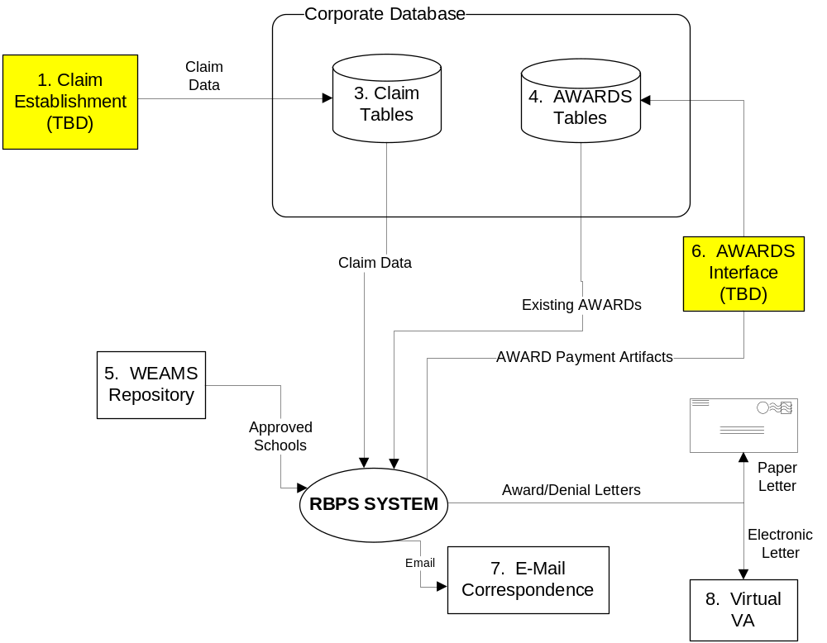
5. Use Case Model

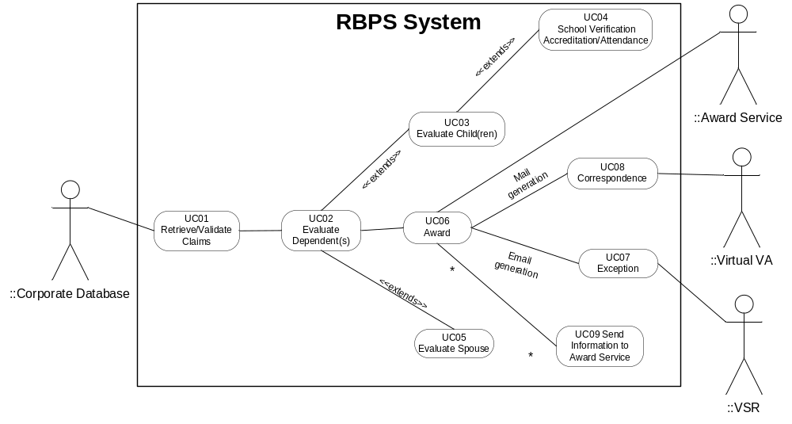

Functional Requirements (Use Cases)

UC-01: Retrieve/Validate Claims
USE CASE SUMMARY
Description | Retrieve/Validate Claims collects the records from the corporate database for automated processing and performs a series of initial checks to determine if the claim is eligible for automated processing. The claims retrieved will be based on the established end product codes (EPs), the form submitted, and the station of jurisdiction (SOJ). A check will also be performed to ensure the claim has not been previously rejected for automated processing. Basic validations will occur on the claim data to identify claims that are not complete or have data in the wrong format (e.g., 7-digit Social Security numbers).  This use case also performs a series of checks based on the Veteran’s data in the corporate database and will result in a determination of the claims eligibility for automated processing. If the claim is not eligible for automated processing, a flag will be set so the claim is not continuously reconsidered. Records not eligible will need to be processed manually.  Claim processing does not occur at this step; it is, instead, a series of checks based on the initial claim data and to evaluate information about the Veteran’s corporate record and current award status.
Actors | Corporate Database
Trigger | Automated batch to retrieve eligible claims.
Pre-Condition | Claim data is available; EP has been established and flagged for automated processing. There will be no other open EP130 or other associated EPs (e.g., EP600/EP290) for the same Veteran.  - The Veteran has been verified (name, address, file number, and running master record)  - The Veteran’s service has been verified.  - Claim SOJ is within scope (Beta Sites)  - The end product must be established and there are no other EP130 series claims pending.  - There will be no EP290 (fugitive felon match, social security prison match and BOP prison match)/EP600 pending; send to exception processing. (increment of claims)  - The claim has been flagged/ labeled for automated processing. (See Appendix G: Claim Labels)  - The claims must be entered/exist in electronic form.
Post-Condition | The claim is ready to proceed with automated processing and is routed based on the end product type. Claims not eligible for automated processing will be marked with the reason and sent for exception processing.
Flow | Retrieve claims and validate the following conditions:  - The Veteran’s claim passes the following checks [CP0012 – Veteran Eligibility for Automated Claim Processing]:  - The Veteran has an active award that exists in the Corporate Database.  - File Number  - Last Name  - Determine if Veteran is living. [CP0008 – Veteran living]  - There have been no changes made to any decision in the Veteran’s award since the last authorized event that have not been generated. This includes rating changes.  - Generate Award Override (GAO) has not been used on the corresponding VETSNET current award.  - Claims previously considered for automated processing will not be retrieved, e.g., only new claims will be processed. [CP0004 – Previous Rejection]  - Submissions containing attachments will be retrieved, processed, and flagged for exception processing (e.g., birth certificate, medical records, marriage license, etc.). [CP0003 – Attachment Check]  - Determine if end product is EP 130 (within scope) and VA form 686c and/or 674 has been submitted for updates to dependency status. [CP0001 - Eligible End Product Check] [CP0005 – Eligible End Product Action].  - Determine that there is no eligible pending claim for the Veteran.  - Veteran/Claimant resides in the US. [CP0007- Resides in US]  - Current award type is Compensation. [CP0102 - Veteran Combined Disability Rating]  - Determine if Veteran has a combined service-connected disability rating >=30%. [CP0102 – Veteran Combined Disability Rating]  - Determine if the Veteran is in receipt of ‘Military Retired Pay’. If yes, send to exception processing. [CP0015 – Military Retired Pay]  - Determine if there is an Attorney fee agreement. If yes, send to exception processing. [CP0016 – Attorney Fee Agreement]
Related Requirements
Business Rules Used | CP0001 -- Eligible End Product Check  CP0003 – Attachment Check  CP0004 – Previous Rejection  CP0005 – Eligible End Product Action  CP0007 - Resides within US  CP0008 – Veteran living  CP0011 – Veteran Corporate Match  CP0012 – Veteran Eligibility for Automated Claim Processing  CP0015 – Military Retired Pay  CP0016 – Attorney Fee Agreement  CP0102 - Veteran Combined Disability Rating
Variations Considered
Frequency of Use
Issues / Assumptions/ Risks | Validations have been performed on claims entered electronically.
Special Requirements

UC-02: Evaluate Dependent(s)
USE CASE SUMMARY
Description | This use case describes the steps to be taken for claims that have completed processing and resulted in either an award change or a denial of the claim. It will determine dependent relationship to Veteran and whether dependent is in corporate database or on current award.
Actors | Corporate database
Trigger
Pre-Condition | Dependent(s) is claimed for the Veteran.
Post-Condition | The relationship to Veteran is evaluated.
Flow | - Verify dependent information against Corporate Database -the dependent of that veteran [CP0100 – Dependent Data] [CP0103 – Determine Current Award Status] [CP0101 - Dependent Data Match]  - Date of Birth  - First Name  - If missing SSN in Corporate, process the claim.  - If SSN mismatch with Corporate, then send to exception processing.  - Verify complete match of dependent or no match to Corporate Database. [CP0101 - Dependent Data Match] [CP0103 - Determine Current Award Status of Dependent]  - Dependent data matches. (SSN, First Name, and DOB match Corporate Database)  - Dependent currently on award. [CP0104 - Evaluate Dependent Award Status]  - Dependent currently not on award.  - Dependent data doesn’t match. (SSN, First Name, and DOB do not match corporate database.)  - Determine relationship type. [CP0013- Determine Relationship Type]  - Evaluate Child(ren) (UC-03: Evaluate Child(ren))  - Evaluate Spouse(s) (UC-05: Evaluate Spouse)  - Determine that number of dependents is not greater than 20, send for exception processing. [CP0130- Number of dependents allowable]
Related Requirements | UC-03: Evaluate Child(ren)  UC-05: Evaluate Spouse
Business Rules Used | CP0100 – Dependent Data  CP0101 – Dependent Data Match  CP0103 – Determine Current Award Status  CP0104 – Evaluate Dependent Award Status  CP0013 – Determine Relationship Type  CP0130 – Number of Dependents Allowable

UC-03: Evaluate Child (ren)
USE CASE SUMMARY
Description | This use case describes the steps to be taken for claims that have completed processing and resulted in either an award change or a denial of the claim. For changes in awards, the need for an initial adjustment and monthly adjustment will be evaluated; the amount of an initial adjustment will be calculated. The award or denial reason and the claim history/audit trail of actions completed will be recorded. The corporate record will be updated as necessary with changes to existing data and ancillary information (diary codes, trigger dates, dependency codes, award adjustment reason codes, A&A codes, entitlement codes, etc.).
Actors | Corporate Database
Trigger
Pre-Condition | The child is claimed as a dependent to the Veteran.  A VA Form 21-686c, Declaration of Status of Dependents has been submitted and an EP130 claim type has been established.  VA Form 21-674, Request for Approval of School Attendance has been submitted for continuation or approval of benefits for a school child - for children between the ages of 18 and 23.
Post-Condition | The date of birth and social security number for the dependent is established and the relationship to the Veteran is evaluated.
Flow | - Validate child date of birth  - Validate child SSN  - If SSN is provided, continue to process  - If SSN is not provided and child is under two years of age, continue to process  - If SSN is not provided and child was not born in the United States, continue to process  - If SSN is not provided and child is over two years of age and born in the US, send to exception for processing and record reasons.[ CP 0142- Child SSN Not Provided]  - Determine relationship types. [CP0108 - Evaluate Childs Relationship Type] [CP0013- Determine Relationship Type]  - Evaluate if child is Biological [CP0109 - Evaluate Biological Child]  - Evaluate if child claimed to be previously married. CP0112 - Child’s Previous Marriage]  - Determine if child is living with the Veteran. [CP0114 - Child’s Address] [CPO133 – Child living with Veteran]. If child is not living with the Veteran then an address is required.(address field needs to filled)  - Determine child age. [CP0115 – Evaluate the Child’s Age]  - Determine if child is a minor. (Minor Child <18 yrs old) [CP0115 - Evaluate the Child’s Age]  - Determine if child is attending school. (School Age Child) [CP0115 - Evaluate the Child’s Age]  - Determine if child is >= 18 years old. [CP0115 - Evaluate the Child’s Age]  - Evaluate if child claimed to be seriously disabled. [CP0113 - Seriously Disabled Indicator]  - Determine if child is attending school. [CP0120 – Determine Type of School]  - UC04: School Verification/Accreditation Attendance  b. Evaluate if child is stepchild. [CP0137 – Determine Event Date Minor Child  - If stepchild address matches the Veteran or is blank then process.  - If stepchild address does not match the Veteran address, send for exception processing.  - Evaluate if child claimed to be previously married. CP0112 - Child’s Previous Marriage]  - Determine child age. [CP0115 – Evaluate the Child’s Age]  - Determine if child is a minor. (Minor Child <18 yrs old) [CP0115 - Evaluate the Child’s Age]  - Determine if child is attending school. (School Age Child) [CP0115 - Evaluate the Child’s Age]  - Determine if child is >= 18 years old. [CP0115 - Evaluate the Child’s Age]  - Evaluate if child claimed to be seriously disabled. [CP0113 - Seriously Disabled Indicator]  - Determine if child is attending school. [CP0120 – Determine Type of School]  - UC04: School Verification/Accreditation Attendance  c. Evaluate if child is adopted. [CP0110 - Evaluate an Adopted Child]
Related Requirements | UC03: School Verification Accreditation/Attendance
Business Rules Used | CP0013 – Determine Relationship Type  CP0108 – Evaluate Child’s Relationship Type  CP0109 – Evaluate Biological Child  CP0110 – Evaluate an Adopted Child  CP0112 – Child’s Previous Marriage  CP0113 – Seriously Disabled Indicator  CP0114 – Child’s Address  CP0115 – Evaluate the Child’s Age  CP0120 – Determine School Type  CP0133 – Child living with Veteran  CP0137 – Determine Event Date Minor Child  CP 0142- Child SSN Not Provided
Variations Considered
Frequency of Use
Issues / Assumptions/ Risks
Special Requirements | For the system to further process claims, the following requirements must be met:  Minor Child (<18 yrs of age)  School Aged Child (>=18 but <23)  Child has to attend an accredited school and attending at least three regular sessions/hours per week.

UC-04: School Verification Accreditation/Attendance
USE CASE SUMMARY
Description | Evaluate if a child between the ages of 18 and < 23 years should be added to or remain or award. This use case can only be applied if the data from school child verification forms is submitted. This use case will evaluate or establish:  - The category of school (post-secondary or high-school)  - When a school is considered approved  - Attending at least three session/hours per week
Actors | Corporate database
Trigger
Pre-Condition | Child is >=18 but <23  Verification of post secondary school accredition in WEAMS/Corporate Database
Post-Condition | Child school accreditation is verified and his/her attendance is captured.
Flow | - Determine type of school [CP0118 - Identify Data Needed for School Child Evaluation] [CP0120 – Determine School Type]  - Determine if child is home schooled, send for exception processing.  - Determine if child is attending high school. [ CP0121 - Evaluate High School]  - Determine if child is attending post secondary school. [CP0122 - Evaluate Post-Secondary School]  - Determine child attendance status:  - Determine if child is attending school full time. [CP0123 – Evaluate Full-Time Status]  - Child is a full time student  - Determine current course start date –[CP0129 –Determine course start date]  - Determine beginning date of last school term  - Determine ending date of last school term  - Determine child’s expected date of graduation Date of graduation or date child turns 23 yrs old, whichever is earlier.  - Child is not getting other education benefits from another federal agency. [CP0119 – Evaluate United States Tuition Payment or Assistance]  - Determine if child is attending school part-time [CP0140 Part-Time Student Status]  - Number of sessions per week  - Number of hours per week
Related Requirements
Business Rules Used | CP011 – Identify Data Needed for School Child Evaluation  CP0119 – Evaluate United States Tuition Payment or Assistance  CP0120 – Determine School Type  CP0121 – Evaluate High School  CP0122 – Evaluate Post-Secondary School  CP0123 – Evaluate Full-Time Status  CP0129 – Determine Course Start Date  CP0140 – Part-Time Student Status
Variations Considered
Frequency of Use
Issues / Assumptions/ Risks
Special Requirements

UC-05: Evaluate Spouse
USE CASE SUMMARY
Description | Evaluate the Veteran and spouse’s marriage history to determine if the spouse can be added to the award.
Actors | Corporate database
Trigger
Pre-Condition | The Veteran is claiming a dependent spouse.
Post-Condition | Established relationship between Veteran and spouse.
Flow | - For Veteran: Validate that all prior marriages have been terminated prior to the begin date of the current marriage. [CP0105 – Evaluate Veteran Previous Marriage]  - For Spouse: Validate that all prior marriages have been terminated prior to the begin date of the current marriage. ([CP0106 – Evaluate Spouse Previous Marriage]  - For Spouse: Validate SSN  - If Spouse SSN is not provided, send for exception processing. [CP0143 Spouse SSN Not Provided]  - If Spouse SSN is provided, continue to process.
Related Requirements
Business Rules Used | CP0105 – Evaluate Veteran Previous Marriage  CP0106 – Evaluate Spouse Previous Marriage  CP 0143- Spouse SSN Not Provided
Variations Considered
Frequency of Use
Issues / Assumptions/ Risks
Special Requirements

UC-06: Award
USE CASE SUMMARY
Description | This use case describes the steps to be taken for claims that have completed processing and resulted in an award, denial, or exception. The system will calculate event date and identify award, denial, and exception reasons completed. The details will be recorded and sent to Awards Service.  Upon completion, Awards Service will provide RBPS information necessary to generate correspondence letters.  Claims that generate exceptions will be forwarded to a designed location.
Actors | Corporate database
Trigger
Pre-Condition | Veteran and dependent information have been verified.
Post-Condition | Determination is either award grant, denial or sent for exception processing.
Flow | - Determine award type (award, denial, exception) and record decision details. Please refer to diagram in Appendix A. [CP0104 – Evaluate Dependent Award Status]  - Award  - Determine Event Date Calculation for each dependent. [CP0107 – Determine Spouse Award Event date] [CP0117 – Determine Minor Step Child Award Event Date] [CP0116 – Determine Biological Minor Child Award Event Date] [CP0125 – Establish the School Child Award Event Date] [CP 0144 Dependent With No Event Date] [CP 0145 Determine Minor to School Child Award Event Date]Add dependent to Corporate Database and establish relationship to the Veteran.[CP0006 – Add dependent to corporate database]  - Pass on information required for dependency decision to Awards Service (UC 09- Send Information to Award Service).  - Awards Service will send back information to RBPS  - UC08: Generate Correspondence. [CP0128 – Generate Correspondence]  - Denial  - If dependent falls into the following list below, review rating decision effective date:  - Over age 18, not a school child or and not seriously disabled  - Over age 23 and not seriously disabled  - Married child  - After review of rating decision effective date If still not within event date rules, deny dependent  - Add dependent to Corporate Database and establish relationship to the Veteran.[CP0006 – Add dependent to corporate database]  - Pass on information required for dependency decision to Awards Service (UC 09- Send Information to Award Service).  - Awards Service will send back information to RBPS  - Generate UC08: Correspondence. [CP0128 – Generate Correspondence]  - Award and Deny  - The Award and Denial sections need to be combined  - Exception [CP0127 – Exception processing]  - Dependents will not be added to the Corporate DB. Relationship will not be established.  - UC- 07 Exceptions
Related Requirements
Business Rules Used | CP0006 – Add dependent to corporate database  CP0104 – Evaluate Dependent Award Status  CP0107 – Determine Spouse Award Effective Date  CP0113 – Seriously Disabled Indicator  CP0115 – Evaluate the Child’s Age  CP0116 – Determine Minor Child Award Effective Date  CP0117 – Determine Minor Step Child Award Effective Date  CP0118 – Identify Data Needed for School Child Evaluation  CP0127 – Exception processing  CP0128 – Generate Correspondence  CP0139 – Determine Event Date School Child  CP0144 – Dependent With No Event Date  CP0145 – Determine Event Date Minor Child to School Child
Variations Considered
Frequency of Use
Issues / Assumptions/ Risks | Potential underpayment of benefits since day of notification is not captured
Special Requirements

UC-07: Exception
USE CASE SUMMARY
Description | This use case describes the process to apply the correct template and populate the e-mail generation for decisions and development actions.
Actors | Corporate database
Trigger
Pre-Condition | One or more exception has been generated for the claim.
Post-Condition | A list of exceptions reasons will be generated and the pending 130s are accessed by the Regional Office
Flow | - A veteran claim has generated an exception. [CP0127 – Exception processing]  - If any exception is generated for any dependent, the entire claim must be passed to exception  - Information with corresponding exception reasoning(s) will be generated daily for all claims. [CP0127 – Exception processing].  - Exception reasons will be placed in MAPD Notes  - Rules trace will be uploaded to Virtual VA
Related Requirements
Business Rules Used | CP0127 – Exception processing
Variations Considered
Frequency of Use
Issues / Assumptions/ Risks
Special Requirements

UC-08: Correspondence
USE CASE SUMMARY
Description | This use case describes the process to apply the correct template and populate the letter template for decisions and development actions.
Actors | Corporate database
Trigger
Pre-Condition | Decision on Award/ Denial has been made and sent to AWARDS Service.  Exceptions have been sent for exception processing
Post-Condition | A letter is generated and ready to be issued. A copy of the correspondence will be sent to Virtual VA.
Flow | - Receive information required to generate the letter from Awards Services.  - The information from Awards Services will be added to predefine correspondence letters.  - The letter shall be sent out daily. [CP0128 – Generate Correspondence]
Related Requirements
Business Rules Used | CP0128 – Generate Correspondence
Variations Considered
Frequency of Use
Issues / Assumptions/ Risks
Special Requirements | See Appendix F: Sample Correspondence Letter

UC 09 – Send Information to Award Service
USE CASE SUMMARY
Description | This use case describes the data that must be sent to the Awards application for the automatic generation of the dependency award.
Actors | Corporate database  Award service
Trigger
Pre-Condition | Decision on Award/ Denial has been made and is ready to be sent to AWARDS Service.
Post-Condition | The awards application receives the data elements necessary to record the dependency decision to generate/authorize a VETSNET Award.
Flow | - RBPS will identify the Veteran by File Number for whom an award adjustment will be made.  - RBPS will determine the following award data elements for each dependent identified as eligible to be added, not denied, as an award dependent.  - Award Status (spouse, minor child, school child, helpless child, not an award dependent)  - Decision  - Event Date(could be >1 if award status = school child)  - Name (First Name and Last Name)  - SSN  - Relationship type (spouse or child)  - Date of Birth  - RBPS will send information to award service
Related Requirements
Business Rules Used | CP0134 Determine Award Status  CP0135 Determine Award Decision  CP0136 Determine Event Date Spouse  CP0137 Determine Event Date Minor Child  CP0138 Determine Event Date Seriously Disabled Child  CP0139 Determine Event Date School Child  CP0140 Determine Event Date when Combined Eval <30%  CP0145 Determine Event Date Minor Child to School Child
Variations Considered
Frequency of Use
Issues / Assumptions/ Risks
Special Requirements

Other Functional Requirements

Creation/Modification of ILog Business Rules
This section is a placeholder for the process of updating the ILog business rules by C&P business users. Authority, configuration, approvals, and documentation will be addressed.

Reporting Requirements
N/A

Summary

Current reporting on work status will remain based on corporate data and retrieved through VOR.

Business Rules

Business Rule ID | Description | Referring Use Case | Laws and Regulations
CP0001 - Eligible End Product Check | Claims will be retrieved based on the end product type; only claims with in-scope end products will be eligible for automated processing. The current planned releases are below:  Release 1 EP 130 Compensation Dependency Changes  (See Appendix G: Claim Labels)  Release 2 EP 155 Eligibility Verification Reports  EP 150 Medical Expense Reports  Release 3 EP 180 Original Disability Pension  EP 190 Original Death Pension  EP 120 Reopened Disability Pension  A new (unique) claim label, for each of the above, to reflect the automatic dependency adjustment needs to be established | UC-01: Retrieve/Validate Claims | N/A
CP0003 – Attachment Check | Submissions containing attachments will be retrieved and processed but will not be sent to Awards Services. Upon running all rules applicable, the claim will be sent for exception processing. | UC-01: Retrieve/Validate Claims | N/A
CP0004 – Previous Rejection | Only new claims shall be processed. | UC-01: Retrieve/Validate Claims | N/A
CP0005 – Eligible End Product Action | Only claims with in-scope end products and product claim labels will be eligible for automated processing.  Release 1 EP 130 Compensation Dependency Changes  - Declaration of Status of Dependents  - Request for Approval of School Attendance  - School Attendance Report  Release 2 EP 155 Eligibility Verification Reports  - Veteran With No Children  - Veteran With Children  - Surviving Spouse With No Children  - Child or Children  - Surviving Spouse With Children  EP 150 Medical Expense Reports  - Medical Expense Report  Release 3 EP 180 Original Disability Pension  EP 190 Original Death Pension  EP 120 Reopened Disability Pension | UC-01: Retrieve/Validate Claims | N/A  M21-1MR III,iii.5.B.5.d, f; CFR 3.205-3.211 (declaration of station of dependents)
CP0006 – Add dependent to corporate database | Information on claim has been validated. If dependent is not on award then add dependent information to corporate database. | UC-02: Evaluate Dependent(s) | 38 CFR 3.50 through 38 CFR 3.60; M21-1 MR Part III, iii5.A.1c
CP0007-  Resides in US | There has been validation of resident address based on information submitted by Veteran/claimant indicating he/she resides within the US or US territories. If Veteran/ claimant do not reside within the US or its territories this will generate an exception. | UC-01: Retrieve/Validate Claims | 38 CFR 3.204; M21-1 MR Part III, iii5.F.33.a
CP0008 – Veteran living | Determine if Veteran is alive. | UC-01 Retrieve/Validate Claims
CP0010 – Data Check | The form (electronic version) used for the claim will be checked to ensure mandatory fields are populated and in the correct format.  The mandatory fields for the 686c and the associated validations are:  - File #  - Last name (matching Corporate DB) | UC-01: Retrieve/Validate Claims
CP0011 – Veteran Corporate Match | The Veteran’s file number matches a record in the corporate database. The records must be an exact match on file number, and last name. | UC-01: Retrieve/Validate Claims
CP0012 – Veteran Eligibility for Automated Claim Processing | The following criteria must be met to continue with automated processing:  - Veteran record exists in the CDB  - There have been no changes made to any decision in the Veteran’s award since the last authorized event that have not been generated. This includes rating changes.  - The corresponding Veteran’s COMPENSATION award is active and has not been suspended or terminated.  - Generate Award Override (GAO) has NOT been used on the corresponding VETSNET current award.  If any of the conditions above are not met, record the reason the claim requires exception processing.  Exception messages:  “Auto Dependency Processing Reject Reason- Changes to the Veterans Last Authorized Award have been made. Please review. “  Auto Dependency Processing Reject Reason – current award is suspended or terminated. Please review.”  “Auto Dependency Processing Reject Reason - Generate Award Override (GAO). Please review | UC-01: Retrieve/Validate Claims
CP0013- Determine Relationship Type | If the EP type is 130 and it was submitted on a VA-686c form, the relationship type is spouse or child(ren). | UC-02: Evaluate Dependent(s) | 38 CFR 3.57; M21-1 MR Part III, iii,5.G.37.a (b)(c); 5.G.38-42
CP0014- Relationship type is Spouse | If the EP type is 130 and it was submitted on a VA-686c form, the relationship type is spouse. | UC-02: Evaluate Dependent(s) | 38 CFR 3.50; M21-1 MR Part III,iii.5.B
CP0015 – Military Retired Pay | If Veteran is in receipt of Military Retire Pay, send claim for exception processing and record reasons. | UC-01: Retrieve/Validate Claims
CP0016 – Attorney Fee Agreement | If Veteran’s running award has Attorney Fee Agreement, send claim for exception process and record reasons. | UC-01: Retrieve/Validate Claims
CP0100 – Dependent Data | Each dependent must have a date of birth, and first and last name. (Last name shall not be matched but should be present). | UC-02: Evaluate Dependent(s) | 38 CFR 3.50; M21-1 MR Part III, iii5.A.1c
CP0101 - Dependent Data Match | The claim is not eligible for automated processing if the SSN matches a record but either the first name or date of birth does not match. The claim is not eligible for automated processing if the date of birth matches a record but either the first name or SSN do not match. Send to exception processing and record the reason. | UC-02: Evaluate Dependent(s) | M21-1MR III.iii.5.B.6; M21-1MR III,iii.5.F.30  38CFR 3.1; 38 CFR3.57
CP0102 - Veteran Combined Disability Rating | If the combined service connected disability rating percentage is less than 30%, send to exception | UC-01: Retrieve/Validate Claims | M21-1MR III,iii.5.A.1
CP0103 - Determine Current Award Status of Dependent | Compare the dependent information submitted on the claim to the Veterans dependent information in the corporate database. The records must be an exact match on SSN, date of birth, and first name. If the dependent is already on the award, record the decision and proceed to evaluating the next dependent. | UC-02: Evaluate Dependent(s) | M21-1MR III.iii.5.
CP0104 - Evaluate Dependent Award Status | If the EP type is 130 and it was submitted on a VA-686c form, send to exception processing since the addition of the dependent as already existing on the award.  RBPS shall send the dependent data to exception processing. | UC-02: Evaluate Dependent(s)  UC 07: Exceptions | M21-1MR III,iii.5.B.5.d, f; CFR 3.205-3.211
CP0105 - Evaluate Veteran Previous Marriage | If the current marriage is the only marriage for Veteran, continue processing. If the Veteran has been previously married, and all prior marriages have been terminated prior to the begin date of the current marriage, continue; else send claims to exception processing and record the reason for exception. | UC-05: Evaluate Spouse | M21-1MR III,iii.5.B.5.d, f, g; CFR 3.205-3.211
CP0106 - Evaluate Spouse Previous Marriage | If the current marriage is the only marriage for the spouse continues processing.  If the spouse has been previously married, and all prior marriages have been terminated prior to the begin date of the current marriage, continue processing; else send for exception processing. | UC-05: Evaluate Spouse | M21-1MR III.iii.5B.e, f
CP0107 - Determine Spouse Award Event Date | If the Veteran's current marriage occurred prior to receiving a 30% disability rating, the Veteran has one year from the date he received 30% to add a spouse with the event date equal to the date the 30% rating., If the claim date if > 1 year of rating date and <= 1+ 30 days, the claim will be sent for exception processing and the reason for exception recorded. If the claim for dependent received >1 + 30 days, the event date of the award will be the date the claim was received.  Otherwise, if the Veteran's marriage occurred after the Veteran received a 30% disability rating; the Veteran has 366 days from the marriage date to add a spouse with the event date equal to the marriage date. If the marriage occurred over 366 days ago, the event date of the award will be the date the claim was received. | UC-06: Award | 38 CFR 3.400 & 3.401; M21-1 MR III,v.2A.1.a
CP0108 - Evaluate Childs Relationship Type | If the child is a biological child of the Veteran, continue to CP0109, Evaluate Biological Child. If the Veteran has adopted the child, continue to CP0110, Evaluate Adopted child. If the child is a Stepchild of the Veteran, continue to CP0111, Evaluate Stepchild. | UC-03: Evaluate Child(ren) | 38 CFR 3.57; M21-1 MR Part III, iii,5.G.37.a (b)(c); 5.G.38-42
CP0109 - Evaluate Biological Child | An automated decision can be determined for a biological child, processing continues to CP 0112 – Child’s Previous Marriage. | UC-03: Evaluate Child(ren) | 38 CFR 3.57
CP0110 - Evaluate an Adopted Child | If the child is adopted, an automated decision cannot be determined for the child. Record the reason for exception. | UC-03: Evaluate Child(ren) | 38 CFR 3.57; M21-1MR III, iii.5.G38.
CP0111 - Evaluate a Stepchild | Rule deleted : BR is covered in CP 0137
CP0112 - Child’s Previous Marriage | If the child is previously married, an automated decision cannot be determined for the child. Send claim for exception processing and record the reason. Continue to CP0113. | UC-03: Evaluate Child(ren) | 38 CFR 3.57; M21-1MR III,iii.5F.30.c
CP0113 - Seriously Disabled Indicator | If the child is said to be seriously disabled and <18, processing can continue.  If child is >=18 and claimed as seriously disabled send claim for exception processing.  Exception message: “Auto Dependency Processing Reject Reason- Child >= 18 and claimed as seriously disabled. Please review.” | UC-03: Evaluate Child(ren) | 38 CFR 3.57; M21-1MR, III, iii, 7.1
CP0114 - Child’s Address | If name of the child is provided then an address must be provided.  If the biological child does not live with the Veteran,  - If address is provided, continue processing  - If address is NOT provided, an automated decision cannot be determined for the child. Send claim for exception processing and record the reason. | UC-03: Evaluate Child(ren) | M21-1 MR III, iii.5.F.31.b
CP0115 - Evaluate the Child’s Age | If the child is >= 18 years old and not determine to be seriously disabled, as of the effective date of the award of 30% or greater, the child cannot be added to the award. If the rating effective date is >= to childs 18th birthday and serious disabled is claimed, send for exception processing and record the reason.  If the child is under 18, the child can be added to the award. If the child is between the ages of 18 and < 23 and is in school, go to CP0118 – Identify Data Needed for School Child Evaluation.  Exception Message: Auto Dependency Processing Reject Reason-Child Rating effective date is after 18th birthday and child is not claimed to be as helpless/seriously disabled. Please review. “ | UC-03: Evaluate Child(ren) | 38 CFR 3.57; M21-1 MR III,iii.6A.1
CP0116 - Determine Biological Minor Child Award Event Date | If the birth of the Veteran's child occurred prior to receiving a > = 30% combined service connected disability rating, the Veteran has one year from the date he received 30% to add the child with the effective date equal to the date the > = 30% combined service connected rating was received. If the rating was one year plus 30 days before the claim date, the claim will be sent for exception processing and the reason for exception recorded. If the rating occurred over one year plus 30 days, the effective date of the award will be the date of claim.  Otherwise, if the child's birth occurred after the Veteran received >= 30% combined service connected disability rating, the Veteran has one year from the child's birthday to add the child with the effective date equal to the child's birthday. If the child's birth occurred over one year plus 30 days before the claim date, the effective date of the award will be the date of claim. | UC-06: Award | 38 CFR 3.400 & 3.401; M21-1 MR III,v.2A.1.a
CP0117 – Determine Step Minor Child Award Event Date | If the birth of the Veteran's child [or parent's marriage to the Veteran] occurred prior to receiving a > = 30% combined service connected disability rating, the Veteran has one year from the date he received 30% to add the child with the effective date equal to the date the > = 30% combined service connected rating was received. If the rating was one year plus 30 days before the claim date, the claim will be sent for exception processing and the reason for exception recorded. If the rating occurred over one year plus 30 days, the effective date of the award will be the date of claim.  Otherwise, if the child's birth [or parent's marriage to the Veteran] occurred after the Veteran received a > = 30% combined service connected disability rating, the Veteran has one year from the child's birthday [or parent's marriage to the Veteran] to add the child with the effective date equal to the child's birthday [or parent's marriage to the Veteran]. If the child's birth or parent's marriage to the Veteran] occurred over one year before the claim date, the effective date of the award will be the date of CLAIM | UC-06: Award | 38 CFR 3.400 & 3.401; M21-1 MR III,v.2A.1.a
CP0118 - Identify Data Needed for School Child Evaluation | If the school information is not available and has not been submitted with the claim, the school child status cannot be evaluated. Send claim to exception processing and record the reason.  If child is enrolled full time then name of school, address of school, name of course of education or training must be submitted. | UC-04: School Verification Accreditation/Attendance | M21-1MR III,iii.6.A.2
CP0119 - Evaluate United States Tuition Payment or Assistance | If the tuition and/or an allowance for the student's education or training is being paid by VA Dependents Educational Assistance (DEA), the Federal Employee's Compensation Act, or any other agency or program of the United States government, the child is not eligible to be added to the award as a school child. Send to exception processing and record the reason. | UC-04: School Verification Accreditation/Attendance | M21-1MR III,iii.6.A.2.g ; 38 USC Chap. 30,31,33 & 35
CP0120 - Determine Type of School | If the child is homeschooled an automated decision cannot be determined for the child. Send claim for exception processing and record the reason. If the child is attending post-secondary school, proceed to CP0122, Evaluate Post Secondary Education for School Child. If the child is attending high school, proceed to CP0121, Evaluate High School Education. | UC-03: Evaluate Child(ren) | M21-1 III,iii.6.A.3.a,b,c,d
CP0121 - Evaluate High School | .If the course of instruction begin date is not provided then send for exception processing.  Exception message: “Auto Dependency Processing Reject Reason- Course of instruction begin date not provided. Please review. “ | UC-04: School Verification/Accreditation Attendance | M21-1MR III,iii.6.A.4.b,c,d
 | Delete rule: RBPS is not checking WEAMS this is precondition
CP0123 - Evaluate Full-Time Status | If the information provided on the claim states the child is attending school full time then proceed with processing. | UC-04: School Verification Accreditation/Attendance | M21-1 MR III.iii.6.A.2.a
 | Delete rule: BR covered in CP 0139
CP0127 – Exception processing | Information regarding all exceptions to include business rules failed/passed and corresponding exception code shall be sent to the Regional Office. | UC-07: Exception
CP0128 – Generate Correspondence | Correspondence will be generated and correct template applied, in order to populate letter for decisions and development actions. A copy of the correspondence will be sent to Virtual VA and letters will be forwarded for daily mailing. | UC-08: Correspondence
CP0129 – Determine Course Start Date | Determine Course start date for student enrolled full-time. If missing send for exception processing. | UC-04  School Validation Accreditation/  Attendance | M21-1 MR III.iii.6.A.2.a
CP0130- Number of dependents allowable | Determine the number of dependents claimed by Veteran. If greater than 20, send for exception processing. | UC-02  Evaluate Dependents
CP0131- Send Information to Awards Service | RBPS will be providing a defined set of data /information to Awards Service. | UC -09: Send information to Award Service
CP0132- Awards Service Sends Information/Data to RBPS | Awards Service will be providing a defined set of data/information to RBPS for correspondence letters. | UC-09: Send information to Award Service
CP0133 – Child living with Veteran | If step child does not live with the Veteran, send claim for exception processing and record the reason. | UC-03 Evaluate Child(ren)
CP0134 Determine Award Status | If claim is received <= 1 year of rating date then  If child is < 18 on rating effective date select Minor child  If child is >= 18 < 23 on rating effective and attending school select School Child  If child is >=18 and <23 on rating effective date and not attending school and not claimed to be seriously disabled select Not an Award Dependent  If child is <18 on rating effective date and attending school select Minor to School Child  If child is >=23 on rating effective date and not claimed to be seriously disabled select Not an Award Dependent.  If Claim is received > 1 Year + 30 days of rating date then  If child is < 18 on Date of Claim Select Minor Child  If child is >= 18 < 23 on Date of Claim and attending school select School Child  If child is <18 on Date of Claim and attending school select Minor to School Child  If child is >=18 and <23 on Date of Claim and not attending school and not claimed to be seriously disabled select Not An Award Dependent  If child is >=23 on rating effective date and not claimed to be seriously disabled select Not an Award Dependent.  Select Spouse if the relationship type is spouse.  Select Not an Award Dependent if the relationship type is child and the following condition applies:  Child of any age is Married | UC-09: Send Information to Award Service
CP0135 Determine Award Decision | If Award Status = Minor Child, set decision = Eligible Minor Child  If Award Status = School Child, set decision = School Attendance Begin Date  For School Child set Decision End Date = Expected date of graduation  Award Status = Minor Child to School Child, set two decisions  1. Eligible Minor Child  2. School Attendance Begin Date  If Award Status = Spouse, set decision = Dependency Established  If Award Status = Not an Award Dependent  1. Child is married, set decision = Marriage.  Rating effective date >= to 23rd birthday of child and not claimed as helpless/seriously disabled, set decision = Rated Not Helpless  Rating effective date >= 18 birthday and < 23rd birthday and not in school or not claimed as helpless/seriously disabled, set decision = Over 18 – Not in School or Helpless. | UC-09: Send Information to Award Service
CP0136 Determine Event Date Spouse | Set the Event Date to the Effective Date of at least 30% combined service connected evaluation if  686c received < = to 1 year of the rating date, and  Veteran marriage date is < = to rating effective date  Set the Event Date to the Date of Marriage if  686c received < = 1 year of the rating date, and  Date of marriage > rating effective date  Or  686c received >1 year + 30 days after rating date, and  686c received <=1 year after date of marriage  Set the Event Date to the Date of Claim if  686c received >1 year + 30 days after rating date, and  686c received > 1 year after date of marriage | UC-09: Send Information to Award Service
CP0137 Determine Event Date Minor Child | Biological Child:  Set the Event Date to the Effective Date of at least 30% combined service connected evaluation if  686c received <= 1 year of rating date, andChild date of birth < the effective date of the rating granting at least 30% combined service-connected evaluation.  Set the Event Date to the Date of Birth if  686c received <=1 year of rating date, and  Date of birth of the child > rating effective date  Or  686c received > 1 year after rating date, and  686c received < = 1 year after date birth of the child  Set the Event Date to the Date of Claim if  686c received > 1 year + 30 days after rating date, and  686c received > 1 year after date of birth of the child
CP0137 Determine Event Date Minor Child | Step-Child only:  Set the Event Date to the Effective Date of at least 30% combined service connected evaluation if  686c received <= 1 year of rating date, and  Child date of birth and Date of Veteran’s Marriage is < to the effective date of the rating granting at least 30% combined service-connected evaluation.  Set the Event Date to the Date of Birth if  Date of birth of the child >= Date of Veteran’s Marriage  And  686c received <= 1 year of rating date, and  Date of birth of the child > rating effective date  Or  686c received > 1 year after rating date, and  686c received <= 1 year after date birth of the child  Set the Event Date to the Date of Claim if  686c received > 1 year + 30 days after rating date, and  686c received > 1 year after date of birthof the child and date of Veteran's marriageSet the Event Date to the Date of Veteran’s Current Marriage if  686c received <= 1 year of the rating date, and  Date of birth of the child < Date of Veteran’s Marriage, and  The Date of the Veteran’s Marriage is > Rating Date  Or  686c received > 1 year after rating date, and  686c received <= 1 year after the date of the marriage, and  686c received> 1 year after date of birth of the child
CP0138 Determine Event Date Seriously Disabled Child | If child is >=18 and claimed as seriously disabled send claim for exception processing | UC-09: Send Information to Award Service
CP0139  Determine Event Date School Child | Biological Child:  Set the Event Date to the Effective Date of at least 30% combined service connected evaluation if  Claim received <= 1 year of rating date, and  Child 18th birthday < = Rating Effective Date, and  Date Course Began <= Rating Effective Date  OR  Claim received <= 1 year of rating dated and  Childs 18th birthday < Rating effective date, and  Date Course Began < 5 months after end date of last term, and  Begin date of last term <Rating effective date  Set the Event Date to the child’s 18th birthday if  Claim received <= 1 year of rating date, and  Child 18th birthday > = Rating Effective Date, and  Date Course Began < 18th birthday  Or  Claim received >1 year+ 30 days after rating effective date and  Claim received <= 1 year of child’s 18th birthday, and  Date Course began < 5 months after the end of last term and  Begin Date of last term >= 18th birthday | UC-09: Send Information to Award Service
CP0139  Determine Event Date School Child | Set the Event Date to the course begin date if  Claim received <= 1 year of rating date, and  Child 18th birthday < Rating Effective Date, and  Date Course Began > Rating Effective Date and  Date Course Began >= 5 months after End Date of last term  Or  Claim received <= 1 year of the Date Course Began, and  Claim received > 1 year + 30 days of rating date, and  Claim received > 1 year of 18th birthday and  Date Course Began > = 5 months after End Date of last term (or there was no attendance last term)  Or  Claim received >1 year + 30 days after rating date, and  Claim received <= 1 year of child’s 18th birthday and  Date Course Began > 5 months after end date of last term, and  Date Course began > 18th birthday | UC-09: Send Information to Award Service
CP0139  Determine Event Date School Child | Set the Event Date to the end date of last term if  Claim received <= 1 year of Date Course Began, and  Date Course Began < 5 months after end date of last term and  Claim received >1 year + 30 days after rating date, and  Claim received >1 year of 18th birthday  Set the Event Date to the date of claim if  Claim received > 1 year + 30 days after rating date  Claim received > 1 year after the child’s 18th birthday  Claim received > 1 year after the Date Course Began | UC-09: Send Information to Award Service
CP0139  Determine Event Date School Child | Step Child:  Set the Event Date to the Effective Date of at least 30% combined service connected evaluation if  Claim received <= 1 year of rating date, and  Child 18th birthday < = Rating Effective Date, and  Date Course Began <= Rating Effective Date and  Marriage Date is < Effective Date of at Least 30% combined service connected evaluation.  OR  Claim received <= 1 year of rating dated and  Childs 18th birthday < Rating effective date, and  Date Course Began < 5 months after end date of last term, and  Begin date of last term <Rating effective date and  Marriage Date is < Effective Date of at Least 30% combined service connected evaluation.  Set the Event Date to the child’s 18th birthday if  Claim received <= 1 year of rating date, and  Child 18th birthday > = Rating Effective Date, and  Date Course Began < 18th birthday and Marriage Date is < child's 18th birthday  Or  Claim received >1 year+ 30 days after rating effective date and  Claim received <= 1 year of child’s 18th birthday, and  Date Course began < 5 months after the end of last term and  Begin Date of last term >= 18th birthday and  Marriage Date is < child's 18th birthday.  Set the Event Date to the course begin date if  Claim received <= 1 year of rating date, and  Child 18th birthday < Rating Effective Date, and  Date Course Began > Rating Effective Date and  Date Course Began >= 5 months after End Date of last term and Marriage Date is <course begin date  Or  Claim received >1 year + 30 days after rating date, and  Claim received <= 1 year of child’s 18th birthday and  Date Course Began > 5 months after end date of last term, and  Date Course began > 18th birthday and Marriage Date is < course begin date.  Set the Event Date to the end date of last term if  Claim received <= 1 year of Date Course Began, and  Date Course Began < 5 months after end date of last term and  Claim received >1 year + 30 days after rating date, and  Claim received >1 year of 18th birthday and Marriage Date is < end date of last term.  Set the Event Date to the date of claim if  Claim received > 1 year + 30 days after rating date  Claim received > 1 year after the child’s 18th birthday  Claim received > 1 year after the Date Course Began and Marriage Date is < the date of claim.  ELSE Set the Event Date to the Marriage Date.
CP0139  Determine Event Date School Child | OR  Claim received <= 1 year of the Date Course Began, and  Claim received > 1 year + 30 days of rating date, and  Claim received > 1 year of 18th birthday and  Date Course Began > = 5 months after End Date of last term (or there was no attendance last term) , and Marriage Date is < course begin date.  Or  Claim received >1 year + 30 days after rating date, and  Claim received <= 1 year of child’s 18th birthday and  Date Course Began > 5 months after end date of last term, and  Date Course began > 18th birthday and Marriage Date is < course begin date.  Set the Event Date to the end date of last term if  Claim received <= 1 year of Date Course Began, and  Date Course Began < 5 months after end date of last term and  Claim received >1 year + 30 days after rating date, and  Claim received >1 year of 18th birthday and Marriage Date is < end date of last term.  Set the Event Date to the date of claim if  Claim received > 1 year + 30 days after rating date  Claim received > 1 year after the child’s 18th birthday  Claim received > 1 year after the Date Course Began and Marriage Date is < the date of claim.  ELSE Set the Event Date to the Marriage Date.
CP0140 – Part-Time Student Status | A child is attending part-time with the following criteria:  (Number of session per week >= 3 or Hours per week >= 3)  And  Name or type of course of education or training  A child is not attending part-time if  (Number of session per week < 3 or Hours per week < 3), send to exception processing | UC-04  School Validation Accreditation/  Attendance
CP 0142- Child SSN Not Provided | If child SSN is not present and  Child age is > = 2 and  Child is residing in USA then send for exception  Exception Message: “Auto Dependency Processing Reject Reason - Dependent SSN was not provided. Please Review.” | UC-03 – Evaluate Child(ren)
CP 0143 – Spouse SSN Not Provided | – Spouse SSN Verification  If spouse SSN is not present then send for exception.  Exception Message : “Auto Dependency Processing Reject Reason - Spouse SSN is not provided. Please review.” | UC-05 – Evaluate Spouse
CP 0144- Dependent With No Event Date | Dependent with no event date :  After processing all rules without exception, If RBPS could not set event date, then send the claim for exception  Exception Message : “Auto Dependency Processing Reject Reason - RBPS could not set the event date for spouse. Please review.” | UC-06 - Award
CP 0145- Determine Event Date Minor Child to School Child | FIRST Event Date:  Biological Child:  Set the Event Date to the Effective Date of at least 30% combined service connected evaluation if  686c received <= 1 year of rating date, and  Child date of birth is < to the effective date of the rating granting at least 30% combined service-connected evaluation.  Set the Event Date to the Date of Birth if  686c received <= 1 year of rating date, and  Date of birth of the child > rating effective date  Set the Event Date to the Date of Claim if  686c received > 1 year + 30 days after rating date, and  686c received > 1 year after date of birth of the child  Step-Child Only :  Set the Event Date to the Effective Date of at least 30% combined service connected evaluation if  686c received <= 1 year of rating date, and  Child date of birth and Date of Veteran’s Marriage is < to the effective date of the rating granting at least 30% combined service-connected evaluation.  Set the Event Date to the Date of Birth if  Date of birth of the child >= Date of Veteran’s Marriage  And  686c received <= 1 year of rating date, and  Date of birth of the child > rating effective date | UC- 09 - Send Information to Award Service
CP 0145- Determine Event Date Minor Child to School Child | Set the Event Date to the Date of Claim if  686c received > 1 year + 30 days after rating date, and  686c received > 1 year after date of birthof the child and date of Veteran's marriage  Set the Event Date to the Date of Veteran’s Current Marriage if  686c received <= 1 year of the rating date, and  Date of birth of the child < Date of Veteran’s Marriage, and  The Date of the Veteran’s Marriage is > Rating Effective Date  Or  686c received > 1 year + 30 days after rating date, and  686c received <= 1 year after the date of the marriage, and  Date of birth of the child < Date of Veteran’s Marriage  SECOND Event Date:  Set the Event Date to the child’s 18th birthday if  Date Course Began <= Child's 18th birthday  OR  Date Course Began < 5 months after End Date of last term and  Begin Date of Last Term <= child's 18th birthday  Set the Event Date to the date course began if  Date Course Began > 5 months after End Date of last term (or there was no attendance last term)  Set the Event Date to the end date of last term if  Date course began < 5 months after end date of last term and  Begin Date of Last Term > child's 18th birthday | UC- 09 - Send Information to Award Service

Non-Functional Requirements

Accessibility
The system shall be available

Audit and Control
Rules will be periodically reviewed and adjusted and/or updated due to Compensation and Pension policy changes and Legislative changes.

Availability
100% availability excluding IT maintenance windows

Backup
RBPS tool shall be backed up on a daily basis
The server will be backed up per Region 5 standard operating procedures

Capacity, Current, and Forecast
The proposed system is expected to support ~ approx: 13,000 users
The annual growth is expected to be 10% users per year
The predicted number of transactions is 7,500.
The transaction profile is expected to grow proportional to the systems users, inventory, and system improvements

Compliance
RBPS will be compliant to Title 38 Code of Federal Regulations and M21-1 MR.

Dependency on other parties
Corporate Database
VETSNET Suite of Applications (Share, MAP-D, etc.)
eBenefits
VONAPP

508 Compliance Requirements
All Section 508 requirements will be adhered to.

Executive Order Requirements
All executive order requirements will be adhered to.

Identity Management Requirements
All Enterprise Identity Management requirements will be adhered to. These requirements are applicable to any application that adds, updates, or performs lookups on persons.

Usability
RBPS will adhere to the Section 508 accessibility guidelines.

Reliability
The RBPS will be accessible and functioning except for maintenance periods. System maintenance activities will be conducted after normal business hours.
All significant defects, as defined in the test plan, will be resolved prior to release. Critical is defined as loss of data or complete inability to use certain parts of the core functionality of the system.
FSC will provide technical help desk support as described for RBPS.

Performance / Response Time
The system shall provide a Performance / End User Response of five (5) seconds at the application layer (User Interface).
The system / architecture shall support two thousand (2,000) concurrent users without systems degradation and thirteen thousand (13,000) internal (VA users) without system degradation.

Enterprise Requirements
Below is a subset of Enterprise Requirements that are of particular interest to the business community. These requirements MUST be addressed within each project resulting from this work effort. If OI&T cannot address these enterprise requirements, the Business Owners responsible for each area MUST be engaged in any waiver discussions prior to any decisions being made. This section is not meant to be a comprehensive list of all enterprise requirements that may apply to this work effort and should not preclude the technical community from reviewing all enterprise requirements, and identifying others that should apply to this work effort as well.

Enterprise requirements are contained in the VA Enterprise Requirements Repository (ERR). To gain access to the repository contact VA OIT OED Enterprise Requirements Management.

Supportability
TBD

Privacy Requirements
All VA Privacy requirements will be adhered to. Efforts that involve the collection and maintenance of employee identifiable information must be covered by a Privacy Act system of records notice.

Security Requirement
The system will meet all applicable VA guidelines and regulations. Specific Requirements to be determined based on existing VA security surrounding ILog business rules applications.

The Security Category is the basis for determining the Certification and Accreditation (C&A) and other security requirements for the work effort. The Security Engineer (SE) assigned to the work effort will assist the stakeholders in the determination of the Security Categorization.

All VA security requirements will be adhered to. Based on Federal Information Processing Standard (FIPS) 199 and National Institute of Standards and Technology (NIST) SP 800-60, recommended Security Categorization is _____________.

The Security Categorization will drive the initial set of minimal security controls required for the information system. Minimum security control requirements are addressed in NIST SP 800-53 and VA Handbook 6500, Appendix D.

Other Non-Functional Requirements
TBD

Information Requirements

Claim Description Data Elements
- Establish the following data elements for each claim:
- EP type
- Original Form Submission (To determine the specific EP action required)
- Status field to indicate claim is being processed by the RBPS. (CRSC uses the Employee Field)
- Indicator for claims that are ineligible for automated processing.

EP 130 Dependency Data Elements
Establish data elements for the following forms:
- 21-686c Declaration of Status of Dependents
- 21-674 Request for Approval of School Attendance
- 21-674b School Attendance Report

Corporate Database Required Fields for Processing
To be determined by the Database working group.

Corporate Database Updates Required Processing Completion
To be determined by the database working group.

Procedural Requirements
The procedural requirements for the following areas will be determined by VBA.

Creation/Modification of ILog Business Rules:
This section is a placeholder for the process of updating the ILog business rules by C&P business users. Authority, configuration, approvals, and documentation will be addressed.

Processing of Exception Claims
This section is a placeholder for the process to complete processing of claims that had exception.

Manual Data Entry of Claims and Claims Establishment:
This section is a placeholder for the process of entering data from paper claim forms so the claim may be processed by the RBPS.

Customer Sign-off

Separate concurrence will be recorded in accordance with PMAS.

Appendix A: Decision Diagram – EP130

Retrieval Decision: UC01: Retrieve/Validate Claims
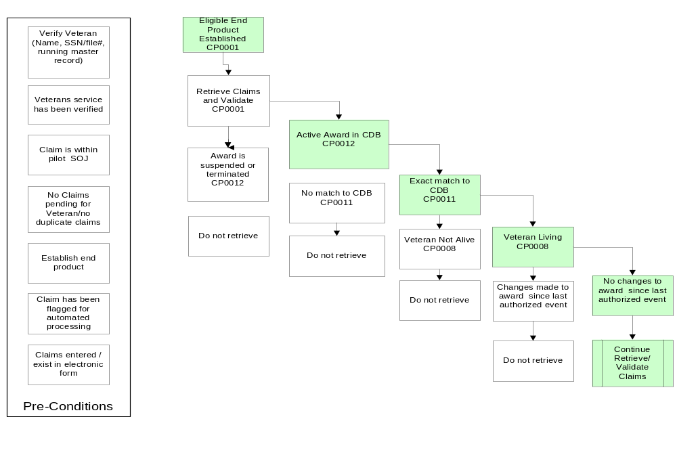
Verify Veteran Record: UC01: Retrieve/Validate Claims
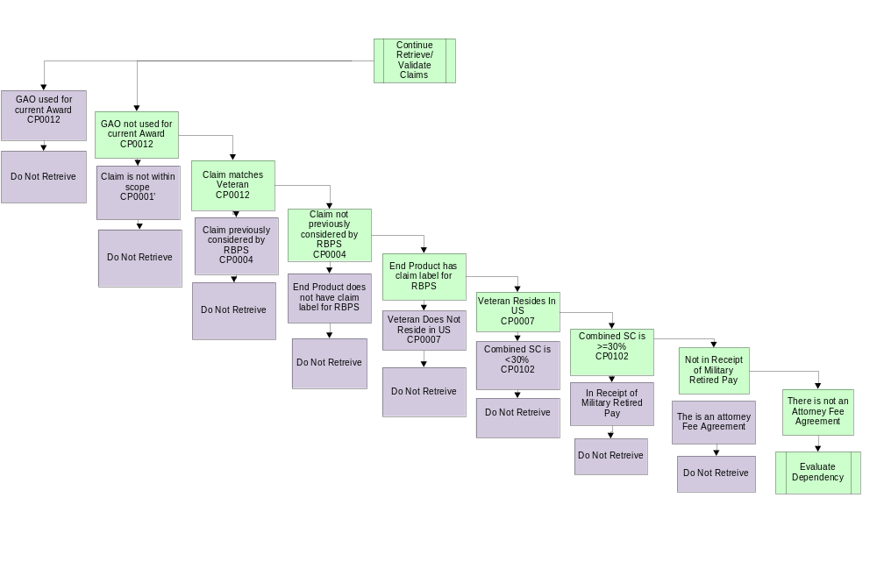
Dependent: UC02: Evaluate Dependent(s)

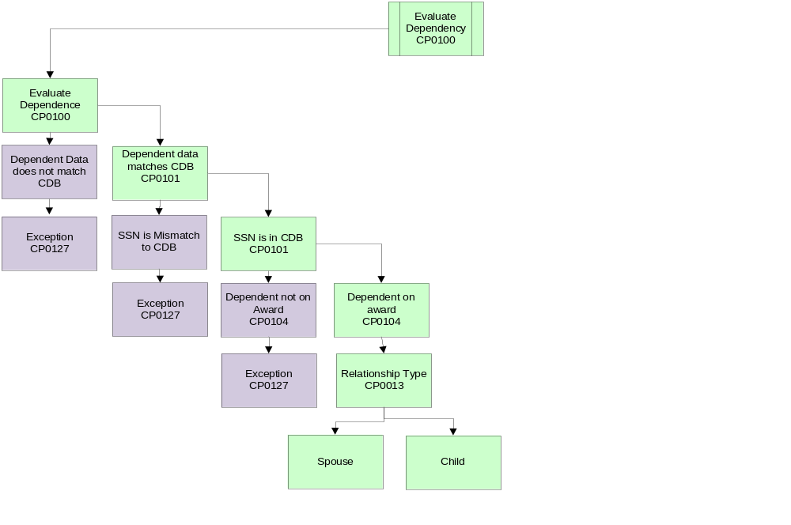

Child: UC03: Evaluate Child(ren)
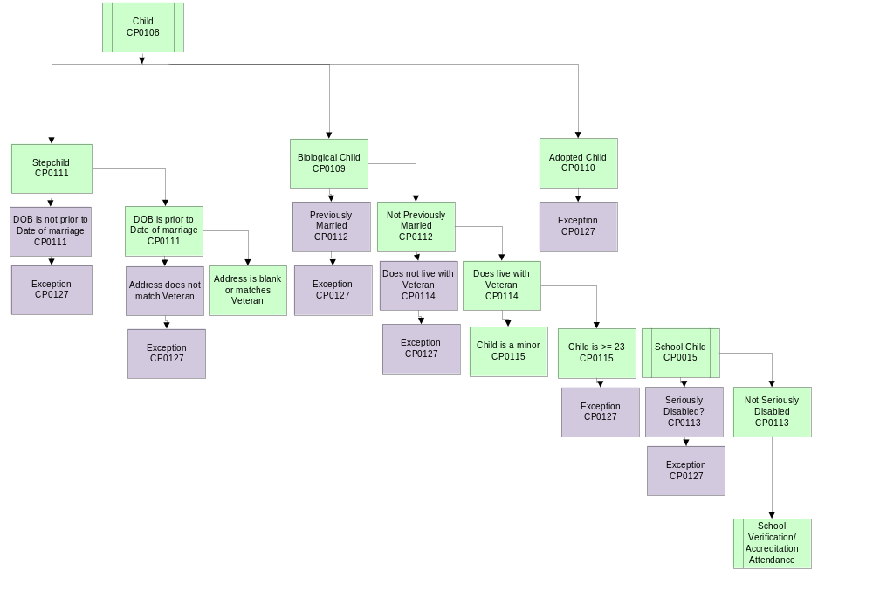
School Child: UC04: School Verification Accreditation/Attendance

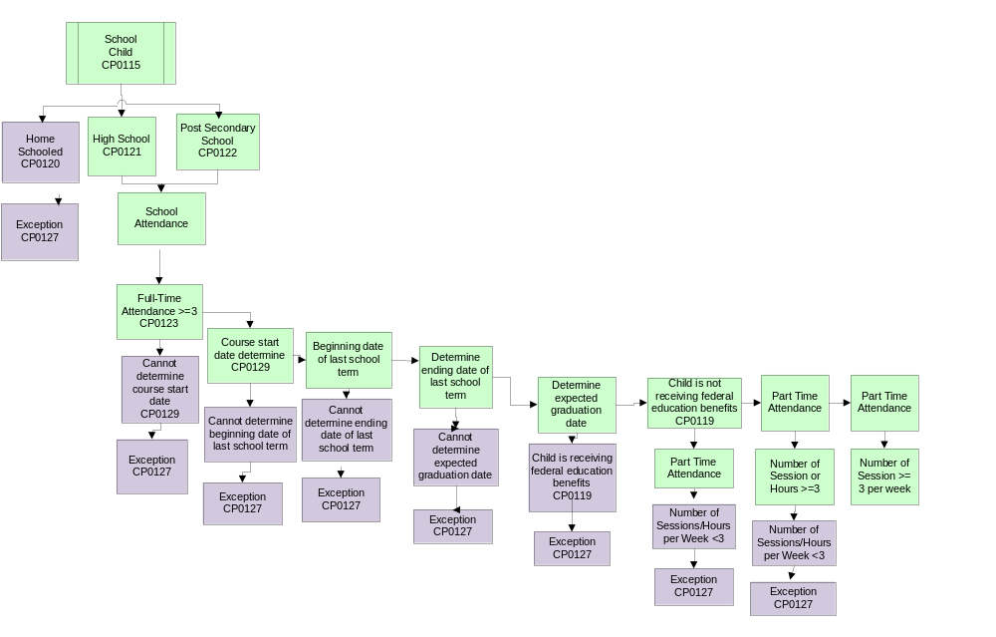
Spouse: UC05: Evaluate Spouse

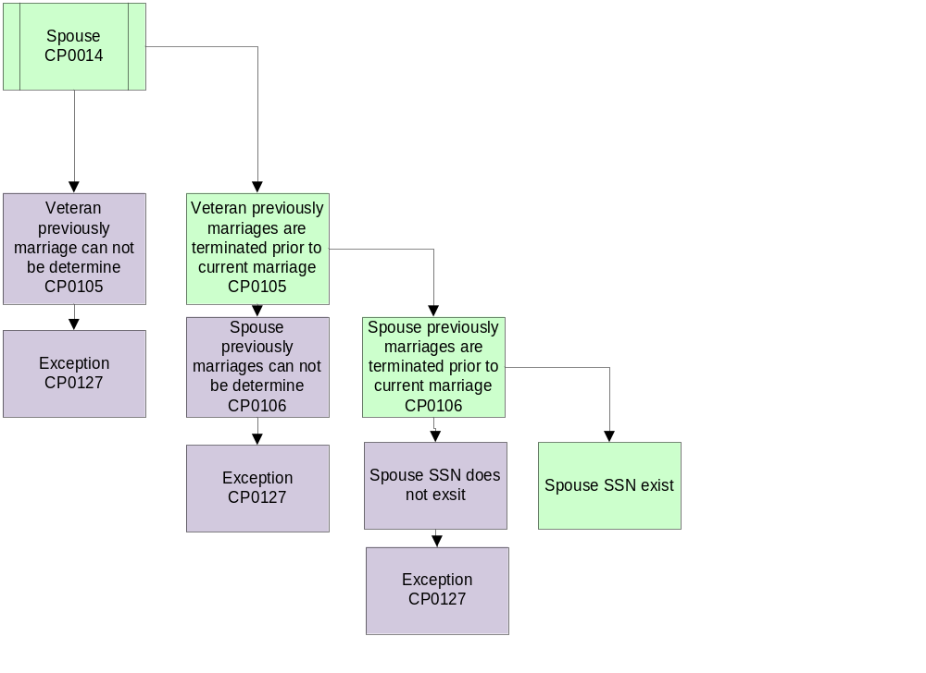

Award Status: UC06: Award
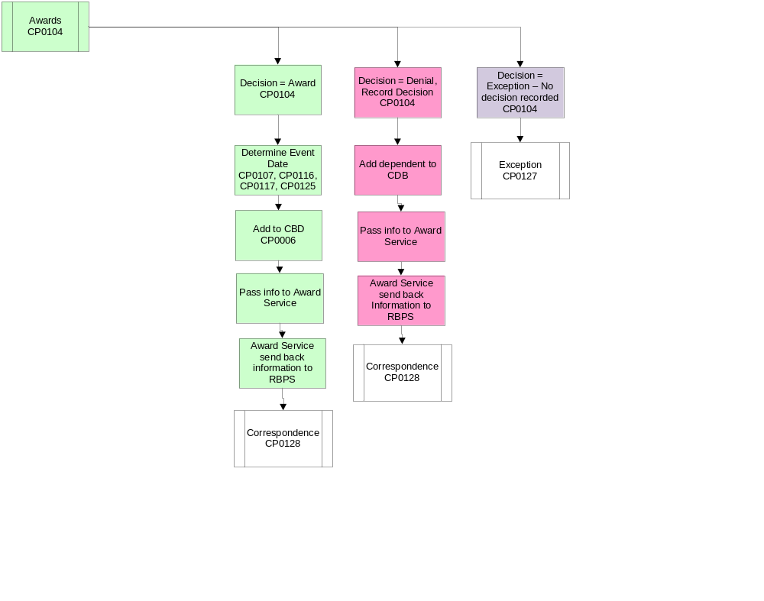

Appendix B: School Child Event Date Scenario
There are five potential event dates for adding a school child dependent.
- Rating Effective date of the earliest rating granting at least a combined of 30% service connected disability.
- 18th Birthday.
- Course begin date.
- End date of last term.
- Date of claim for the dependent.
Three basic groups of scenarios exist for adding a school child.
- Claimed child not currently on the award.
- Claimed child currently established as a minor child award dependent where the latest decision = Turns 18.
- Claimed child currently established as a school child award dependent where the latest decision = School Attendance Terminates or Turns 23.
Basic Rules
Claimed child not currently on the award
Claim received within 1 year of rating date

Child 18th birthday < rating date
Date school started < rating date
Pay from rating effective date
Date school started > rating date
Pay from course begin date

Child 18th birthday > rating date
Date course began < 5 months after Ending Date of last term
Pay from 18th birthday
Date course began > 5 months after Ending Date of last term
Pay from course begin date

Claim received between 1 year and 1 year + 15 days
Refer for review
Claim received more than 1 year + 15 days of rating date
Claim received within 1 year of child 18th birthday
Date course began < 5 months after Ending Date of last term
Pay from 18th birthday
Date course began > 5 months after Ending Date of last term
Pay from course begin date
Claim received > 1 year after child 18th birthday
Claim received within one year of course start date
Pay from course begin date
Claim received > 1 year after course start date
Pay from date of claim

Claimed child currently established as a minor child award dependent where the latest decision = Turns 18.
Claim received within 1 year of 18th birthday
Course begin date < 5 months after end date of last term
Pay from 18th birthday
Course begin date > 5 months after end date of last term
Pay from course begin date
Not attending school at end of last school term
Pay from course begin date

Claim received > 1 year after 18th birthday
Claim received < 1 year after course begin date
Pay from course begin date
Claim received > 1 year after course begin date
Pay from date of claim

Note – this 5-month designation needs concurrence from the group and Procedures.
Basis for selecting 5 months:
High School ends 05-02-10
College Starts 09-04-10
This is more than 4 months

Claimed child currently established as a school child award dependent where the latest decision = School Attendance Terminates or Turns 23.

Claim received within 1 year of course begin date
Course begin date < 5 months after end date of last term
Pay from end date of last term
Course begin date > 5 months after end date of last term
Pay from course begin date
Not attending school at end of last school term
Pay from course begin date

Claim received > 1 year after course begin date
Pay from date of claim

Scenario 1
Claimed child not currently on the award
Claim received within 1 year of rating date

Child 18th birthday < rating effective date
Date school started < rating effective date
Pay from rating effective date

Important Dates (potential event dates marked with *)

Rating Date | 10-02-2010
*Rating Effective Date | 09-08-2010
*Child 18th Birthday | 04-03-2009
*End Date Last Term | 05-14-2010
*Date Student Starts/Started Course | 09-04-2010
Expected Graduation Date | 05-01-2013
*Date of Claim | 11-12-2010

Select Event Date:

Rating Effective Date? Yes. Since the Veteran provided all of the information about the dependent’s school attendance within one year of when entitlement arose, we will pay from the Rating Effective Date.

Child 18th Birthday? No. We cannot add child before the effective date of the 30% or more sc evaluation.

End Date of Last Term? No. This event occurred prior to rating effective date since child already enrolled in current school term on that date.

Date Student Starts/Started Course? No. The 674 indicates the student was enrolled last term and will be/are enrolled during the next term.

Date of Claim? No. The claim was received within one year of the rating date, so we can go back to rating effective date of the 30% or more sc grant.

Scenario 2:
Claimed child not currently on the award
Claim received within 1 year of rating date
Child 18th birthday < rating effective date
Date school started > rating effective date
Pay from course begin date

Important Dates (potential event dates marked with *)

Rating Date | 10-02-2010
*Rating Effective Date | 09-08-2010
*Child 18th Birthday | 04-03-2009
*End Date Last Term | Null
*Date Student Starts/Started Course | 01-01-2011
Expected Graduation Date | 05-01-2013
*Date of Claim | 11-12-2010

Select Event Date:

Rating Effective Date? No. Since the child was over 18 and not attending school on that date, we cannot add the child at this point.

Child 18th Birthday? No. We cannot add child before the effective date of the 30% or more sc evaluation.

End Date of Last Term? No. The Veteran indicated the child was not enrolled for the prior term.

Date Student Starts/Started Course? Yes. The was received within 1 year of the date the course started.

Date of Claim? No. The claim was received within one year of the rating date, so we can go back to rating effective date of the 30% or more sc grant.

Scenario 3:
Claimed child not currently on the award
Claim received within 1 year of rating date
Child 18th birthday > rating date
Date course began < 5 months after Ending Date of last term
Pay as minor child from rating effective date
Pay as school child from 18th birthday

In this scenario – we will have more than one event date since we must first add the child as a minor child, then change status to school child.

Important Dates (potential event dates marked with *)

Rating Date | 10-02-2010
*Rating Effective Date | 09-08-2010
*Child 18th Birthday | 12-13-2010
*End Date Last Term | 05-14-2010
*Date Student Starts/Started Course | 08-25-2010
Expected Graduation Date | 05-15-2011
*Date of Claim | 02-10-2011

Select Event Date:

Rating Effective Date? Yes to add minor child. Add the child as a minor child on this date since the 686c was received within one year of the rating date.

Child 18th Birthday? Yes to continue as school child. Change the status to school child. The claim was received within one year of the child’s 18th birthday and the student was enrolled on that date.

End Date of Last Term? No. This event occurred prior to the child’s 18th birthday.

Date Student Starts/Started Course? No. In this case, the date was prior to the 18th birthday.

Date of Claim? No. The claim was received within one year of the rating date, so we can go back to rating effective date of the 30% or more sc grant to add the minor child. Also No for updating to School Child because the claim was received within one year of the18th birthday.

Scenario 4:
Claimed child not currently on the award
Claim received within 1 year of rating date
Child 18th birthday > rating date
Date course began > 5 months after Ending Date of last term
Pay as minor child from rating effective date
Pay as school child from course begin date

In this scenario – we will have more than one event date since we must first add the child as a minor child, then change status to school child.

Important Dates (potential event dates marked with *)

Rating Date | 10-02-2010
*Rating Effective Date | 09-08-2010
*Child 18th Birthday | 12-13-2010
End Date Last Term | 05-14-2010
*Date Student Starts/Started Course | 01-07-2011
Expected Graduation Date | 05-02-2013
*Date of Claim | 02-10-2011

Select Event Date:

Rating Effective Date? Yes to add minor child. Add the child as a minor child on this date since the 686c was received within one year of the rating date.

Child 18th Birthday? No. The 674 indicates that there was more than a 5-month break between the end date of the last term and the date the student started school.

End Date of Last Term? No. There is more than 5 months between this date and the course begin date. No break pay.

Date Student Starts/Started Course? Yes to begin the school child rate. The student was not enrolled in school continuously from the 18th birthday, so we must begin the school child benefit from the date school started.

Date of Claim? No. The claim was received within one year of the rating date, so we can go back to rating effective date of the 30% or more sc grant to add the minor child. Also No for updating to School Child because the claim was received within one year of course begin date.
Scenario 5:
Claim received more than 1 year + 15 days of rating date
Claim received within 1 year of child 18th birthday
Date course began < 5 months after Ending Date of last term
Pay from 18th birthday

Important Dates (potential event dates marked with *)

Rating Date | 05-05-2009
*Rating Effective Date | 05-05-2008
*Child 18th Birthday | 04-23-2010
*End Date Last Term | 05-13-2010
*Date Student Starts/Started Course | 09-02-2010
Expected Graduation Date | 05-05-2014
*Date of Claim | 01-13-2011

Select Event Date:

Rating Effective Date? No. The dependent child was claimed more than 1 year + 15 days after the rating date.

Child 18th Birthday? Yes. The 674 was received within 1 year of the child’s 18th birthday and the dates indicate the child was enrolled in school on that date and continued enrollment at the beginning of the next term.

End Date of Last Term? No. This date is > 18th birthday and we can go back to the 18th birthday if there was con

Date Student Starts/Started Course? No. We can use the 18th birthday since the claim was received within 1 year of that date and the child was continuously enrolled from that date.

Date of Claim? No. Since the claim was received within 1 year of the 18th birthday and school entitlement was continuous from the 18th birthday.

Scenario 6:
Claim received more than 1 year + 15 days of rating date
Claim received within 1 year of child 18th birthday
Date course began > 5 months after Ending Date of last term
Pay from course begin date

Important Dates (potential event dates marked with *)

Rating Date | 05-05-2009
*Rating Effective Date | 05-05-2008
*Child 18th Birthday | 04-23-2010
End Date Last Term | 05-13-2010
*Date Student Starts/Started Course | 01-03-2011
Expected Graduation Date | 05-05-2014
*Date of Claim | 01-13-2011

Select Event Date:

Rating Effective Date? No. The dependent child was claimed more than 1 year + 15 days after the rating date.

Child 18th Birthday? No. The 674 was received within 1 year of the child’s 18th birthday, but the child was not enrolled continuously from that date.

Date Student Starts/Started Course? Yes. Since the last term ended > 5 months ago and the claim was received within one year of the course begin date, we can use this date as the event date for adding the school child.

Date of Claim? No. Since the claim was received within 1 year of the date the course began.
Scenario 7:
Claim received more than 1 year + 15 days after rating date
Claim received > 1 year after child 18th birthday
Claim received within one year of course start date
Pay from course begin date

Important Dates (potential event dates marked with *)

Rating Date | 05-05-2009
*Rating Effective Date | 05-05-2008
*Child 18th Birthday | 11-15-2009
End Date Last Term | 05-13-2010
*Date Student Starts/Started Course | 01-07-2011
Expected Graduation Date | 05-05-2014
*Date of Claim | 01-02-2011

Select Event Date:

Rating Effective Date? No. The dependent child was claimed more than 1 year + 15 days after the rating date.

Child 18th Birthday? No. The 674 was received > 1 year after the child’s 18th birthday, and the child was not continuously enrolled from that date.

Date Student Starts/Started Course? Yes. Since the last term ended > 5 months prior to the course begin date and the claim was received within one year of the course begin date, we can use this date as the event date for adding the school child.

Date of Claim? No. Since the claim was received within 1 year of the course begin date.

Scenario 8:
Claim received more than 1 year + 15 days of rating date
Claim received > 1 year after child 18th birthday
Claim received > 1 year after course start date
Pay from date of claim

Important Dates (potential event dates marked with *)

Rating Date | 05-05-2009
*Rating Effective Date | 05-05-2008
*Child 18th Birthday | 11-15-2009
End Date Last Term | 05-13-2010
*Date Student Starts/Started Course | 09-02-2009
Expected Graduation Date | 05-05-2014
*Date of Claim | 01-13-2011
Select Event Date:

Rating Effective Date? No. The dependent child was claimed more than 1 year + 15 days after the rating date.

Child 18th Birthday? No. The 674 was received > 1 year after the child’s 18th birthday, and > 1 year after the course begin date.

Date Student Starts/Started Course? No. The course started > 1 year prior to the date of claim.

Date of Claim? Yes. All other potential event dates occurred > 1 year prior to the date of claim, so we must use the date of claim as the event date for adding the child.

Scenario 9:
Claimed child currently established as a minor child award dependent where the latest decision = Turns 18
Claim received within 1 year of 18th birthday
Course begin date < 5 months after end date of last term
Pay from 18th birthday

Important Dates (potential event dates marked with *)

Rating Date | 05-05-2009
*Rating Effective Date | 05-05-2008
*Child 18th Birthday | 06-02-2010
End Date Last Term | 05-13-2010
*Date Student Starts/Started Course | 09-02-2010
Expected Graduation Date | 05-05-2014
*Date of Claim | 09-04-2010

Select Event Date:

Rating Effective Date? No. The dependent child has already been added as an award dependent – so this is not an event date to consider.

Child 18th Birthday? Yes. The 674 was received within 1 year of the child’s 18th birthday, and there was less than a 5-month break between the end of the last term and the course begin date.

Date Student Starts/Started Course? No. Since the child was enrolled in the prior term, continuous enrollment is conceded and we will start from the 18th birthday.

Date of Claim? No. We would only use the date of claim if it were > than the 18th birthday and > the course begin date.

Scenario 10:
Claimed child currently established as a minor child award dependent where the latest decision = Turns 18
Claim received within 1 year of 18th birthday
Course begin date > 5 months after end date of last term
Pay from course begin date

Important Dates (potential event dates marked with *)

Rating Date | 05-05-2009
*Rating Effective Date | 05-05-2008
*Child 18th Birthday | 01-03-2010
End Date Last Term | 05-13-2010
*Date Student Starts/Started Course | 11-02-2010
Expected Graduation Date | 05-05-2014
*Date of Claim | 11-11-2010
Select Event Date:

Rating Effective Date? No. The dependent child has already been added as an award dependent – so this is not an event date to consider.

Child 18th Birthday? No. Although the 674 was received within 1 year of the 18th birthday, the child was not continuously enrolled as noted by the break between terms of more than 5 months.

Date Student Starts/Started Course? Yes. The school start date is not one year or more before the date of claim.

Date of Claim? No. We would only use the date of claim if it were > than the 18th birthday and > the course begin date.

Scenario 11:
Claimed child currently established as a minor child award dependent where the latest decision = Turns 18
Claim received within 1 year of 18th birthday
Not attending school at end of last school term
Pay from course begin date

Important Dates (potential event dates marked with *)

Rating Date | 05-05-2009
*Rating Effective Date | 05-05-2008
*Child 18th Birthday | 11-15-2009
End Date Last Term | 05-13-2010
*Date Student Starts/Started Course | 09-02-2009
Expected Graduation Date | 05-05-2014
*Date of Claim | 01-13-2011

Select Event Date:

Rating Effective Date? No. The dependent child has already been added as an award dependent – so this is not an event date to consider.

Child 18th Birthday? No. Although the 674 was received within 1 year of the 18th birthday, the child was not attending school at the end of the last school term. (either look at block 11A or compare Course begin date to End Date of Last Term)

Date Student Starts/Started Course? Yes. The school start date is not more than one year prior to the date of claim and there was no attendance during the prior term.

Date of Claim? No. We would only use the date of claim if it were > than the 18th birthday and > the course begin date.

Scenario 12:
Claimed child currently established as a minor child award dependent where the latest decision = Turns 18
Claim received > 1 year after 18th birthday
Claim received < 1 year after course begin date
Pay from course begin date

Important Dates (potential event dates marked with *)

Rating Date | 05-05-2009
*Rating Effective Date | 05-05-2008
*Child 18th Birthday | 11-15-2009
End Date Last Term | 05-13-2010
*Date Student Starts/Started Course | 09-02-2009
Expected Graduation Date | 05-05-2014
*Date of Claim | 01-13-2011

Select Event Date:

Rating Effective Date? No. The dependent child has already been added as an award dependent – so this is not an event date to consider.

Child 18th Birthday? No. The 674 was received > 1 year after the 18th birthday.

Date Student Starts/Started Course? Yes. The date of claim is < 1 year after the course begin date.

Date of Claim? No. We would only use the date of claim if it were > than the 18th birthday and > the course begin date.

Scenario 13:
Claimed child currently established as a minor child award dependent where the latest decision = Turns 18
Claim received > 1 year after 18th birthday
Claim received > 1 year after course begin date
Pay from date of claim

Important Dates (potential event dates marked with *)

Rating Date | 05-05-2009
*Rating Effective Date | 05-05-2008
*Child 18th Birthday | 11-15-2009
End Date Last Term | 05-13-2010
*Date Student Starts/Started Course | 01-01-2010
Expected Graduation Date | 05-05-2014
*Date of Claim | 02-05-2011

Select Event Date:

Rating Effective Date? No. The dependent child has already been added as an award dependent – so this is not an event date to consider.

Child 18th Birthday? No. The 674 was received > 1 year after the 18th birthday.

Date Student Starts/Started Course? No. The 674 was received > 1 year after the course begin date.

Date of Claim? Yes. All other potential event dates occurred more than one year prior to the date of claim.
Scenario 14:
Claimed child currently established as a school child award dependent where the latest decision = School Attendance Terminates or Turns 23.
Claim received within 1 year of course begin date
Course begin date < 5 months after end date of last term
Pay from end date of last term

Important Dates (potential event dates marked with *)

Rating Date | 05-05-2009
*Rating Effective Date | 05-05-2008
*Child 18th Birthday | 11-15-2009
*End Date Last Term | 05-13-2010
*Date Student Starts/Started Course | 09-02-2010
Expected Graduation Date | 05-05-2014
*Date of Claim | 02-05-2011

Select Event Date:

Rating Effective Date? No. The dependent child has already been added as an award dependent – so this is not an event date to consider.

Child 18th Birthday? No. The dependent is already established as a school child.

End Date of Last Term? Yes. The student has restarted school within 5 months of the end date of the last term so we can consider this continuous enrollment to pay for the break.

Date Student Starts/Started Course? No. Since we are within 5 months of the date school attendance terminated, we can start back up on the prior stop date.

Date of Claim? No. The 674 was received within one year of the begin date of the course.

Scenario 15:
Claimed child currently established as a school child award dependent where the latest decision = School Attendance Terminates or Turns 23.
Claim received within 1 year of course begin date
Course begin date > 5 months after end date of last term
Pay from course begin date

Important Dates (potential event dates marked with *)

Rating Date | 05-05-2009
*Rating Effective Date | 05-05-2008
*Child 18th Birthday | 11-15-2009
*End Date Last Term | 05-13-2010
*Date Student Starts/Started Course | 01-03-2011
Expected Graduation Date | 05-05-2014
*Date of Claim | 02-05-2011

Select Event Date:

Rating Effective Date? No. The dependent child has already been added as an award dependent – so this is not an event date to consider.

Child 18th Birthday? No. The 674 was received > 1 year after the 18th birthday.

End Date of Last Term? No. The break between courses was more than 5 months.

Date Student Starts/Started Course? Yes. There was a break in enrollment so we cannot consider break pay, we must start from the date school resumed.

Date of Claim? No. The 674 was received within one year of the begin date of the course.

Scenario 16:
Claimed child currently established as a school child award dependent where the latest decision = School Attendance Terminates or Turns 23.
Claim received within 1 year of course begin date
Not attending school at end of last school term
Pay from course begin date

Important Dates (potential event dates marked with *)

Rating Date | 05-05-2009
*Rating Effective Date | 05-05-2008
*Child 18th Birthday | 11-15-2009
*End Date Last Term | Null
*Date Student Starts/Started Course | 09-03-2010
Expected Graduation Date | 05-05-2014
*Date of Claim | 02-05-2011

Select Event Date:

Rating Effective Date? No. The dependent child has already been added as an award dependent – so this is not an event date to consider.

Child 18th Birthday? No. The 674 was received > 1 year after the 18th birthday.

End Date of Last Term? N/A. The Veteran indicated the child was not enrolled during the last term.

Date Student Starts/Started Course? Yes. The 674 was received < 1 year after the course begin date.

Date of Claim? No. The 674 was received within one year of the begin date of the course
Scenario 17:
Claimed child currently established as a school child award dependent where the latest decision = School Attendance Terminates or Turns 23.
Claim received > 1 year after course begin date
Pay from date of claim

Important Dates (potential event dates marked with *)

Rating Date | 05-05-2009
*Rating Effective Date | 05-05-2008
*Child 18th Birthday | 11-15-2009
End Date Last Term | 12-18-2009
*Date Student Starts/Started Course | 01-07-2010
Expected Graduation Date | 05-05-2014
*Date of Claim | 02-05-2011

Select Event Date:

Rating Effective Date? No. The dependent child has already been added as an award dependent – so this is not an event date to consider.

Child 18th Birthday? No. The 674 was received > 1 year after the 18th birthday.

End Date of Last Term? No. Since the course began > 1 year prior to the date of claim, we cannot consider this date.

Date Student Starts/Started Course? No. The 674 was received > 1 year after the course begin date.

Date of Claim? Yes. All other potential event dates occurred more than one year prior to the date of claim.

What if 686c/674 received together to add child for the first time who starts as minor child and changes to schoolchild?

Veteran entries on the 674

9b: Expects to start school 09-02-10
9c: Expected graduation date of 05-05-14
11e: Beginning date of last term 01-03-10
11f: Ending date of last term 05-25-10

Claim received 07-07-10
Rating was completed 02-04-10
Combined SC evaluation of 30% effective 09-09-2009
Child turns 18 on 10-14-2009
Child still in high school until 05-25-10
Child starts college 09-02-10

Event dates to send to Awards

Add minor child --- event date will be rating effective date since claim received within 1 year of rating date.

Do we remove on 18th bday? No, in school in May and to restart in September.

Change to school child --- event date will be 18th birthday because we pay the break (<5 months between end of last term and beginning of next term).

Future removal of school child --- event date will be expected date of graduation.

This scenario has the life event dates of 18th bday, end of last term, and start date of course all close together. The rules should be pretty good for this one.

Potential Event Dates for Adding a School Child

Event Date | Use If:
Eff Date of at least 30% combined s service connected evaluation | - Claim received within one year of rating date  - Child 18th birthday < Rating Effective Date  - Date Course Began < Rating Effective Date
18th Birthday | - Claim received within one year of rating date  - Child 18th birthday > Rating Effective Date  - Date Course Began < 5 months after End Date of last term  Or  - Claim received more than 1 year + 15 days after rating date  - Claim received within 1 year of child’s 18th birthday  - Date Course Began < 5 months after end date of last term
Course Begin Date | - Claim received within one year of rating date  - Child 18th birthday < Rating Effective Date  - Date Course Began > Rating Effective Date  Or  - Claim received within one year of the Date Course Began  - Child 18th birthday > Rating Effective Date  - Date Course Began > 5 months after End Date of last term  Or  - Claim received more than 1 year + 15 days after rating date  - Claim received within 1 year of child’s 18th birthday  - Date Course Began > 5 months after End Date of last term  Or  - Claim received more than 1 year + 15 days after rating date  - Claim received > 1 year after the child’s 18th birthday  - Claim received within 1 year of the Date Course Began
End Date of Last Term
Date of Claim | - Claim received more than 1 year + 15 days after rating date  - Claim received > 1 year after the child’s 18th birthday  - Claim received > 1 year after the Date Course Began

Appendix C: Seriously Disable Child Even Date Scenario
There are three potential event dates for adding a seriously disabled child/stepchild dependent.
- Rating Effective date of the earliest rating granting at least a combined of 30%.
- Child’s 18th birthday.
- Date of claim for seriously disabled child determination.

Scenario 1 --- pay from the effective date of the earliest rating granting at least 30% service connected as a combined evaluation

Database shows a seriously disabled/helpless child rating determination has been made for the child claimant.

Important Dates (potential event dates marked with *)

Rating Date | 08-08-2009
*Rating Effective Date | 04-23-2008
*Child 18th Birthday | 04-03-2007
*Date of Claim | 06-03-2010

Select Event Date:

Rating Effective Date? Yes. The child was over 18 on that date, the claim was received within one year of the rating date, and there is a rating indicating that the child was seriously disabled prior to age 18.
Child 18th Birthday? No. This event occurred prior to the rating effective date.
Date of Claim? No. The claim was received within one year of the rating date.

Scenario 2 --- pay from the 18th birthday of the child

Database shows a helpless child rating determination has been made for the child claimant.

Important Dates (potential event dates marked with *)

Rating Date | 08-08-2009
*Rating Effective Date | 04-23-2008
*Child 18th Birthday | 07-21-2010
*Date of Claim | 09-02-2010

Select Event Date:

Rating Effective Date? No. The child was not yet 18 on this date.
Child 18th Birthday? Yes. The claim was received within one year of this event and there is a helpless child rating of record.
Date of Claim? No. The claim was received within one year of one of the other potential events (the 18th birthday)– so we can use the 18th birthday event date.

Scenario 3: Use date of claim

Database shows a helpless child rating determination has been made for the child claimant.

Important Dates (potential event dates marked with *)

Rating Date | 08-08-2009
*Rating Effective Date | 04-23-2008
*Child 18th Birthday | 01-17-2008
*Date of Claim | 11-15-2010

Select Event Date:

Rating Effective Date? No The claim was received more than one year after the rating date.
Child 18th Birthday? No. The claim was received more than one year after this event.
Date of Claim? Yes. The claim was received more than a year after the other two potential event dates.

Potential Event Dates for Adding a Seriously Disabled Child

Event Date | Use If:
Eff Date of at least 30% combined s service connected evaluation  (Rating Effective Date) | - 686c received within 1 year of rating date, and  - The child is at least 18 on that date, and  - A rating has been completed determining that the child is helpless/seriously disabled
18th Birthday | - 686c received with 1 year of rating date, and  - Child’s 18th birthday > rating effective date  - A rating has been completed, and determining that the child is helpless/seriously disabled  Or  - 686c received > 1 year after rating date, and  - 686c received < 1 year after the child’s 18th birthday, and  - A rating has been completed determining that the child is helpless/seriously disabled.
Date of Claim | - 686c received > 1 year + 15 days after rating date, and  - 686c received > 1 year after the child’s 18th birthday  - A rating has been completed determining that the child is helpless/seriously disabled

Appendix D: Minor Stepchild Even Date Scenario
There are four potential event dates for adding a stepchild dependent.
- Rating Effective date of the earliest rating granting at least a combined of 30% service connected disability.
- Date of Birth.
- Date of veteran’s current marriage (here we will have to assume the child belongs to the current spouse of the veteran and entered household on date of marriage).
- Date of claim for the dependent.

Scenario 1 --- pay from the effective date of the earliest rating granting at least 30% service connected as a combined evaluation.

Important Dates (potential event dates marked with *)

Rating Date | 08-08-2009
*Rating Effective Date | 04-23-2008
*Child Date of Birth | 07-04-2000
*Date of Veteran’s Marriage | 08-02-2007
*Date of Claim | 04-02-2010

Select Event Date:

Rating Effective Date? Yes. Since the Veteran provided all of the information about the dependent within one year of when entitlement arose (the Rating Effective Date), and was already married to the child’s biological parent, we will pay from the Rating Effective Date.

Child Date of Birth? No. The child was born prior to the rating effective date. We cannot add child before the effective date of the 30% or more sc evaluation.

Date of Veteran’s Marriage? No. This event occurred prior to the rating effective date.

Date of Claim? No. The claim was received within one year of the rating date, so we can go back to the latest of all other potential event dates: the Rating Effective Date of the 30% or more sc grant.

Scenario 2: Pay from the date of birth of stepchild

Important Dates (potential event dates marked with *)

Rating Date | 08-08-2009
*Rating Effective Date | 04-23-2008
*Child Date of Birth | 10-04-2009
*Date of Veteran’s Marriage | 05-24-2009
*Date of Claim | 12-23-2009

Select Event Date:

Rating Effective Date? No. The child was not yet born as of this date.

Child Date of Birth? Yes. The earliest potential date would be the date of birth.

Date of Veteran’s Marriage? No. The child was not yet born.

Date of Claim? No. The claim was received within one year of the rating date, so we can go back to the latest of the other potential event dates.

Scenario 3: Pay from the date of the Veteran’s current marriage.

Important Dates (potential event dates marked with *)

Rating Date | 08-08-2009
*Rating Effective Date | 04-23-2008
*Child Date of Birth | 02-15-2008
*Date of Veteran’s Marriage | 10-31-2010
*Date of Claim | 12-23-2010

Select Event Date:

Rating Effective Date? No. The Veteran was not yet married to the child’s parent on that date.

Child Date of Birth? No. The child was born prior to the rating effective date. We cannot add child before the effective date of the 30% or more sc evaluation.

Date of Veteran’s Marriage? Yes. The Veteran claimed the dependent within one year of the marriage to the child’s biological parent.

Date of Claim? No. The dependent was claimed within one year of the life event (marriage to child’s parent). We can go back to the date of that event.

Scenario 4: Pay from the date of claim

Important Dates (potential event dates marked with *)

Rating Date | 08-08-2009
*Rating Effective Date | 04-23-2008
*Child Date of Birth | 07-04-2004
*Date of Veteran’s Marriage | 09-08-2006
*Date of Claim | 01-12-2011

Select Event Date:

Rating Effective Date? No. The dependent was not claimed within one year of the rating date.

Child Date of Birth? No. The child was born prior to the rating effective date. We cannot add child before the effective date of the 30% or more sc evaluation.

Date of Veteran’s Marriage? No. This event occurred more than one year prior to the date of claim.

Date of Claim? Yes. We cannot use any of the other potential event dates because they all occurred more than one year prior to the date of claim.

Potential Event Dates for Adding a Minor Step Child

Event Date | Use If:
Eff Date of at least 30% combined s service connected evaluation  (the Rating Effective Date) | - 686c received within 1 year of rating date, and  - Child date of birth is prior to the effective date of the rating granting at least 30% combined service-connected evaluation.
Date of Birth | - 686c received with 1 year of rating date, and  - Date of birth of the child > rating effective date  Or  - 686c received > 1 year after rating date, and  - 686 received < 1 year after date birth of the child
Date of Veteran’s Current Marriage | - 686c received within 1 year of the rating date, and  - Date of birth of the child < Date of Veteran’s Marriage, and  - The Date of the Veteran’s Marriage is > Rating Date  Or  - 686c received > 1 year after rating date, and  - 686c received < 1 year after the date of the marriage
Date of Claim | 686c received > 1 year + 15 days after rating date, and  686c received> 1 year after date of birth of the child

Appendix E: Minor Biological Child Event Date Scenario
There are three potential event dates for adding a minor biological child:

- Rating Effective date of the earliest rating granting at least a combined of 30% service connected disability.
- Date of birth.
- Date of claim for the dependent.

Scenario 1 --- pay from the effective date of the earliest rating granting at least 30% service connected as a combined evaluation

Important Dates (potential event dates marked with *)

Rating Date | 08-08-2009
*Rating Effective Date | 04-23-2008
*Child Date of Birth | 07-04-2000
*Date of Claim | 04-02-2010

Select Event Date:

Rating Effective Date? Yes. Since the Veteran provided all of the information about the dependent within one year of when entitlement arose (the Rating Date), we will pay from the Rating Effective Date.

Child Date of Birth? No. The child was born prior to the Rating Effective date. We cannot add child before the effective date of the 30% or more sc evaluation.

Date of Claim? No. The claim was received within one year of the Rating Date, so we can go back to the latest of the other potential event dates: the Rating Effective Date of the 30% or more sc grant.

Scenario 2: Pay from the date of birth

Important Dates (potential event dates marked with *)

Rating Date | 08-08-2009
*Rating Effective Date | 04-23-2008
*Child Date of Birth | 02-14-2010
*Date of Claim | 04-02-2010

Select Event Date:

Rating Effective Date? No. The child was not yet born on this date. .

Child Date of Birth? Yes. The earliest date from which we can pay is the date of birth of the child.

Date of Claim? No. The claim was received within one year of the rating date and/or child date of birth, so we can go back to the later of the other two potential event dates – the Date of Birth.

Scenario 3: Pay from the date of claim

Important Dates (potential event dates marked with *)

Rating Date | 08-08-2008
*Rating Effective Date | 04-23-2008
*Child Date of Birth | 07-04-2009
*Date of Claim | 01-21-2011

Select Event Date:

Rating Effective Date? No. The child was not yet born on this date.

Child Date of Birth? No. The claim was not filed within a year of this event.

Date of Claim? Yes. The claim was received more than one year after all other potential event dates, so the Date of Claim is the only event date we can consider.

Potential Event Dates for Adding a Minor Biological Child

Event Date | Use If:
Eff Date of at least 30% combined s service connected evaluation  (the Rating Effective Date) | - 686c received within 1 year of rating date, and  - Child date of birth is prior to the effective date of the rating granting at least 30% combined service-connected evaluation.
Date of Birth | - 686c received with 1 year of rating date, and  - Date of birth of the child > rating effective date  Or  - 686c received > 1 year after rating date, and  - 686c received < 1 year after date birth of the child
Date of Claim | - 686c received > 1 year + 15 days after rating date, and  - 686c received > 1 year after date of birth of the child

Appendix E: Spouse Event Date Scenario
There are three potential event dates you would send to the Awards application to add a spouse dependent

- Rating Effective date of the earliest rating granting at least a combined of 30% service connected disability.
- Date of marriage.
- Date of claim for the dependent.

Scenario 1 --- pay from the effective date of the earliest rating granting at least 30% service connected as a combined evaluation.

Important Dates (potential event dates marked with *)

Rating Date | 08-08-2009
*Rating Effective Date | 04-23-2008
*Date of Marriage | 04-02-2000
*Date of Claim | 04-02-2010

Select Event Date:

Rating Effective Date? Yes. The claim was received within one year of the rating date and the veteran was married on that date.

Date of Marriage? No. Marriage occurred prior to rating effective date. We could not go back this far to add the spouse.

Date of Claim? No. The claim was received within one year of the rating date.

Scenario 2: Pay from the date of marriage

Important Dates (potential event dates marked with *)

Rating Date | 08-08-2009
*Rating Effective Date | 04-23-2008
*Date of Marriage | 02-03-2010
*Date of Claim | 04-02-2010

Select Event Date:

Rating Effective Date? No. Although the claim was received within one year of the rating date, the veteran was not married on that date and we couldn’t add the spouse dependent any earlier than the date of marriage.

Date of Marriage? Yes. Marriage occurred after the rating effective date. We can add the spouse as early as the date of marriage.

Date of Claim? No. The claim was received within one year of the rating date – so we would use one of the other potential event dates.

Scenario 3: Pay from the date of claim

Important Dates (potential event dates marked with *)

Rating Date | 08-08-2009
*Rating Effective Date | 04-23-2008
*Date of Marriage | 12-04-2009
*Date of Claim | 01-12-2011

Select Event Date:

Rating Effective Date? No. The claim was not received within one year of the rating date.

Date of Marriage? No. The claim was not received within one year of the date of marriage.

Date of Claim? Yes. Since the information was received more than one year after all of the other potential event dates, we must use the date of claim as the event date.

Rules for Adding a Dependent Spouse

Event Date | Use If:
Eff Date of at least 30% combined service connected evaluation  (aka Rating Effective Date) | - 686c received within 1 year of the rating date, and  - Veteran already married on this date
Date of Marriage | - 686c received with 1 year of the rating date, and  - Date of marriage > rating date  Or  - 686c received > 1 year + 15 days after rating date, and  - 686c received < 1 year after date of marriage
Date of Claim | - 686c received more than 1 year + 15 days after rating date, and  - 686c received > 1 year after date of marriage

Appendix F: Sample Correspondence Letter



Appendix G: Claim Labels
The End Products established will be:
130 – Automated Dependency 686c
130 – Automated School Attendance 674
130 – PMC Automated Dependency 686c
130 – PMC Automated School Attendance 674
If the claim fails within the Rules Based Processing System, RBPS will generate an exception; the above claim labels will be changed via RBPS to what is defined below:
130 – Automated Dependency 686c Reject
130 – Automated School Attendance 674 Reject
130 – PMC Automated Dependency 686c Reject
130 – PMC Automated School Attendance 674 Reject
Share will also display the 130s that are established via the eBenefits portal. These are:
130 – eBenefits Dependency Adjustment
130 – eBenefits Request for Approval of School Attendance
130 – eBenefits Dependency Adjustment Reject
130 – eBenefits Request for Approval of School Attendance Reject

EP 290 exceptions should be limited to only those with the claim labels as follows:
290 – Fugitive Felon
290 – Bureau of Prisons
290 – Social Security Prison Match

Appendix H: MAPD Notes Exception Processing



